DailyMealBox

AMENDMENT v2 Extra
Final Gap Audit · Dynamic Slots · Information Visibility · 26 New Items

Document | Amendment v2 — Final Gap Audit
Date | 10 June 2026
Builds on | Amendment v2 (18 items) + Amendment v2 Pantry Box (8 items)
New items | 26 items: Dynamic slot system + competitor gaps + information visibility + UX gaps
New screens | 11 new/updated screens included in this document
New ACM controls | ACM-146 to ACM-160 (15 new controls, total now 160)
Status | FINAL — after this amendment PRDs are complete

FINAL AMENDMENT: This is the fourth and FINAL amendment to all DailyMealBox PRD documents. After this is added, the PRDs are complete. All 26 items are organized by Part (1–4). Each item has: what is missing, what to build, and updated screen mockup where applicable.
ACM UPDATE: NEW ACM RANGE: ACM-146 to ACM-160. Running total is now 160 admin controls across all 5 apps. Add all new ACMs to the Admin Controls Matrix document (currently v2.1).

Master Index — All 26 New Items

Gap | Title | Screens Affected | Priority | Add to Part
A | Dynamic Delivery Slot System — admin adds/removes slots | CA-05, AP-08 | P0 | Parts 1+4
B | Driver Attendance Tracking | DA-11, AP-06 | P0 | Parts 3+4
C | Annual / Yearly Subscription Plan | CA-07, AP-03 | P1 | Parts 1+4
D | Discounted Trial / Free First Week | CA-06, AP-03 | P1 | Parts 1+4
E | Live Stock Tracking for Vendors | VM-07, VM-NEW-01 | P1 | Part 2+4
F | Bad Debt Customer Report | AP-11 | P1 | Part 4
G | Business Holiday / Platform Closure Planning | AP-08 | P1 | Part 4
H | Google Analytics Integration | AP-09 | P1 | Part 4
I | Mailchimp Email Marketing Integration | AP-09, AP-13 | P1 | Part 4
J | WhatsApp Invoice Delivery | CA-v2-07 | P1 | Part 1
K | Zone-Based Delivery Pricing | AP-08 | P2 | Part 4
L | Fortnightly Subscription Option | CA-05, CA-07 | P2 | Part 1
M | Pre-Order for New Meal Launches | VM-06, VM-07, CA-09 | P2 | Parts 1+2
N | Data Encryption Documented in PRD | AP-09 | P0 | Part 4
O | Information Visibility Controls Per User Type | AP-03, All apps | P1 | All Parts
P | Return / Unsold Pantry Stock Tracking | VM-04, DA-07 | P1 | Parts 2+3
Q | Custom Day Selection Per Subscription | CA-05 | P1 | Part 1
R | Separated Meal / Delivery / Overall Ratings | CA-14, AP-05/06 | P1 | Parts 1+4
S | Subscription Upgrade / Downgrade Flow | CA-08, CA-15 | P0 | Part 1
T | Vendor Response to Customer Reviews | VM-09, AP-05 | P1 | Parts 2+4
U | Customer Address Validation Against Zones | CA-02, CA-15 | P0 | Part 1
V | Multiple Delivery Addresses Per Day | CA-15 | P1 | Part 1
W | Granular Notification Preferences | CA-15 | P1 | Part 1
X | Area-Specific Product Availability (explicit) | CA-09 | P1 | Part 1
Y | Customer Group / Segment Allocation | AP-11, AP-13 | P2 | Part 4
Z | Driver Availability Confirmation (24h before shift) | DA-11 | P1 | Part 3

PART 1 — Customer App — Part 1
12 new items in this section

GAP A Dynamic Delivery Slot System [P0]
GAP C Annual / Yearly Subscription Plan [P1]
GAP D Discounted Trial / Free First Week [P1]
GAP J WhatsApp Invoice Delivery [P1]
GAP L Fortnightly Subscription Option [P2]
GAP Q Custom Day Selection Per Subscription [P1]
GAP R Separated Meal / Delivery / Overall Ratings [P1]
GAP S Subscription Upgrade / Downgrade Flow [P0]
GAP U Customer Address Validation Against Zones [P0]
GAP V Multiple Delivery Addresses Per Day [P1]
GAP W Granular Notification Preferences [P1]
GAP X Area-Specific Product Availability [P1]

GAP A — Dynamic Delivery Slot System
Screen: CA-05 Delivery Schedule + AP-08 City Management Priority: P0 Add to: Parts 1 + 4
MISSING: CRITICAL GAP. Currently the PRD has 3 hardcoded slots: Breakfast / Lunch / Dinner. Admin can enable/disable these but CANNOT add new slots, rename slots, or change their times without a developer. This must be a fully dynamic system — admin owns the slot list entirely.
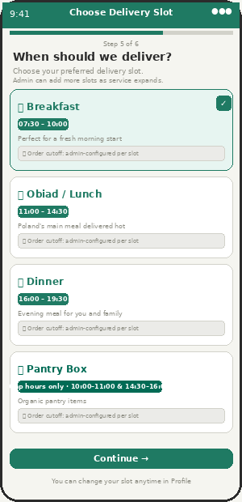  CA-05 — Customer chooses from admin-configured slots | 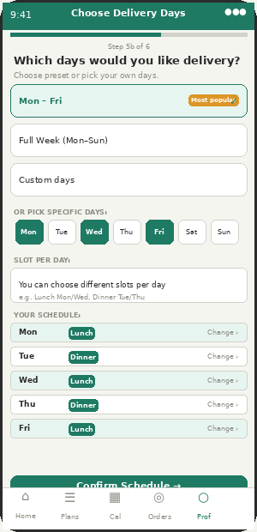  CA-05b — Custom day + per-day slot selection

Aspect | Detail | What Appzeto Builds
What customer sees in CA-05 | A list of delivery slots configured by admin. Each slot shows: name, time window, and cutoff info. Customer selects one (or multiple for different days). Only enabled slots for their city are shown. | GET /api/slots?city=warsaw returns admin-configured active slots. CA-05 renders dynamically from this list — not hardcoded.
Admin creates/edits slots in AP-08 | Admin adds slot: name, start time, end time, cutoff time, available days (Mon-Fri / Mon-Sun / specific days), city scope, linked driver shift. OTA push — customer app updates within 15 min. | slot_types collection: {slot_id, name, start_time, end_time, cutoff_time, available_days[], city, linked_shift_type, status: active|draft}
Admin removes/disables a slot | Admin switches slot to OFF — disappears from CA-05 for new subscribers. Existing subscribers on that slot: admin sees affected count and sends migration notification. | slot.status = disabled. Existing subscriptions: flag as needs_slot_change. Customer prompted to choose new slot on next app open.
Slot linked to driver shift | Each slot MUST link to a driver shift. Cannot have a delivery slot without a corresponding driver shift. System enforces this — admin blocked from creating orphan slot. | slot.linked_shift_type: breakfast|obiad|dinner|pantry_gap1|pantry_gap2|custom. Admin must select shift when creating slot.
Custom day selection | Beyond Mon-Fri / Full Week: customer can pick specific days (e.g. Mon+Wed+Fri only). Admin enables custom day selection per city via ACM-146. | subscription.delivery_days: array of day numbers [1,3,5] for Mon/Wed/Fri. Calendar and billing calculated from this array.
Per-day different slots | Customer can have Lunch on Mon/Wed/Fri and Dinner on Tue/Thu. Admin enables per ACM-147. | subscription.day_slots: {monday: slot_id_lunch, tuesday: slot_id_dinner, ...}. Displayed on CA-12 Calendar per day.

NEW ACM: New ACM controls: ACM-146 (enable custom day selection) · ACM-147 (enable per-day different slots) · ACM-148 (max slots per customer per day)
GAP S — Subscription Upgrade / Downgrade Flow
Screen: CA-08 Home + CA-15 Profile Priority: P0 Add to: Part 1
MISSING FLOW: CA-08 has a "Change" quick action button but the actual change flow was never designed. What happens when customer upgrades from weekly to monthly? Or switches vendor? Or adds a second slot? This flow must be explicitly documented.
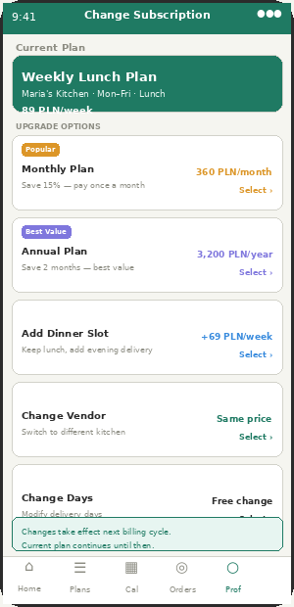
CA-15 — Upgrade / Downgrade / Change options

Aspect | Detail | What Appzeto Builds
Upgrade weekly → monthly | Customer taps Change in CA-08 or navigates to CA-15. Selects "Monthly Plan." System shows: price difference, next billing date, and "Changes take effect next billing cycle" notice. | subscription.plan_change_pending: {new_plan, effective_date: next_billing_cycle}. Not immediate — applied at end of current period.
Upgrade to annual plan | Customer selects Annual plan. Pays full annual amount upfront. Current weekly/monthly subscription cancelled at end of current period. Annual begins immediately after. | Annual plan billing: single charge of annual_price. subscription.billing_cycle: annual. Renewal reminder: 30 days before annual expiry.
Switch vendor | Customer selects Change Vendor. Browse CA-09 Plans for new vendor in same zone. Select new vendor + plan. Change effective from next Monday. | Old subscription.status: cancelling (end of current week). New subscription created: starts next Monday. Both shown on CA-12 during transition week.
Add second slot (add Dinner to existing Lunch) | Customer selects Add Delivery Slot. Chooses additional slot and vendor. Second subscription created. Billed separately. | Two active subscriptions allowed. Each billed independently. CA-12 Calendar shows both slots per day.
Downgrade monthly → weekly | Customer selects Downgrade. System warns: "You will lose X days of prepaid period. Credit added to wallet for unused days." | Pro-rata credit for unused monthly days → wallet. New weekly subscription starts next Monday.
What stays the same | Delivery address, allergen preferences, loyalty points, invoice preference — all carry over to new plan automatically. | subscription.user_preferences_carry_over: true. No re-onboarding needed.

GAP U — Customer Address Validation Against Delivery Zones
Screen: CA-02 GPS + CA-15 Profile Addresses Priority: P0 Add to: Part 1
MISSING: When customer enters a delivery address, the system must validate it falls within an active delivery zone. Without this, customers outside delivery zones can subscribe but cannot be delivered to. Critical data quality issue.
Aspect | Detail | What Appzeto Builds
At GPS detection (CA-02) | Auto-detected location matched against GeoJSON zone polygons. If outside all zones: "We don't deliver to your area yet. Deliveries coming soon." Cannot proceed to onboarding with undeliverable address. | db.zones.findOne({boundary: {$geoIntersects: {$geometry: {type:"Point", coordinates:[lng,lat]}}}}) — returns zone or null.
When customer adds address (CA-15) | Customer enters address → Google Maps Geocoding converts to coordinates → zone match check → if no zone match: red error "This address is outside our delivery area." | Same zone match logic. Address rejected before saving if outside all zones. Suggest nearest available zone if applicable.
When customer changes address mid-subscription | If new address is in different zone → check if current vendor delivers to new zone → if not: warn customer "Your current vendor doesn't deliver here. Choose a new vendor?" | subscription.zone_mismatch_detected: true. Customer prompted to select new vendor for new zone before address change saves.
Admin sees undeliverable attempts | AP-11 Analytics: "Addresses attempted outside zones" report. Useful for identifying where to expand next. | Log all failed zone validations: coordinates, timestamp, city_attempted. Admin report: expansion demand map.

GAP V — Multiple Delivery Addresses Per Day
Screen: CA-15 Profile → Addresses Priority: P1 Add to: Part 1
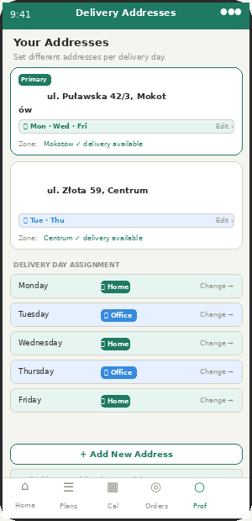
CA-15 — Multiple addresses with per-day assignment

Aspect | Detail | What Appzeto Builds
Save multiple addresses | Customer saves: Home, Office, and up to 3 custom addresses. Each validated against delivery zones on save. | user.delivery_addresses: [{label, address, coordinates, zone_id, is_primary}] max 5 entries.
Assign address per delivery day | Monday/Wednesday/Friday → Home. Tuesday/Thursday → Office. Different address per day of week. | subscription.day_addresses: {monday: address_id_home, tuesday: address_id_office, ...}. Driver DA-04 manifest shows correct address per delivery.
Zone validation per address | Each address must be in a delivery zone. If customer saves office address in zone that has no vendors → warning shown. | Each saved address has zone_id field. CA-09 Plans filtered by day's assigned address zone when customer browses plans.
Quick switch on Calendar | CA-12: tap any upcoming delivery day → option to change address for that specific day only (one-off change, not permanent). | One-off address override: order.delivery_address_override. Does not change default day assignment.

GAP Q+W — Custom Day Selection + Granular Notification Preferences
Screen: CA-05 + CA-15 Priority: P1 Add to: Part 1
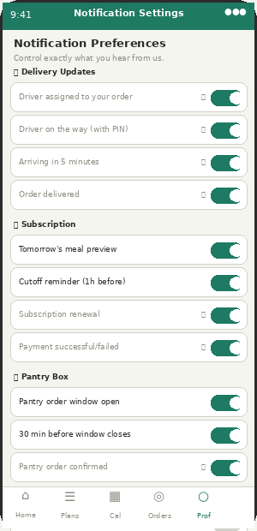
CA-15 — Granular notification preferences by category

Aspect | Detail | What Appzeto Builds
Custom day selection (Gap Q) | Beyond Mon-Fri or Full Week: customer picks specific days. E.g. Mon+Wed+Fri only, or just Tue+Thu. Admin enables per ACM-146. | subscription.delivery_days: [1,3,5] (Mon/Wed/Fri). Billing pro-rated for selected days only.
Notification categories (Gap W) | Customer controls each notification category independently. 4 categories: Delivery Updates / Subscription / Pantry Box / Promotions. Each category has sub-toggles. | user.notification_preferences: {delivery_updates: {driver_assigned:true, arriving:true}, subscription: {tomorrow_preview:true}, pantry: {window_open:false}, promotions: {flash_deals:false}}
Cannot disable critical notifications | Order delivered, payment failed, subscription cancelled — cannot be turned off. Shown with lock icon in CA-15 Notifications. | notification_type.can_disable: boolean. Lock icon shown in UI. Toggle rendered as disabled.
Admin overrides customer preference | Admin (ACM-131+) can force certain notifications to all customers regardless of their preference setting. E.g. emergency platform maintenance notice. | admin_force_notify: array of notification_types. Customer preference ignored for forced types. Logged in audit trail.

GAP R — Separated Meal / Delivery / Overall Ratings
Screen: CA-14 Order Detail (post-delivery) Priority: P1 Add to: Parts 1 + 4
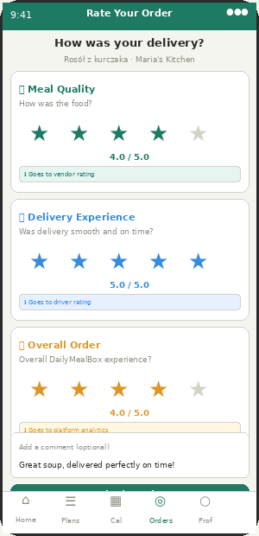
CA-14 — Three separate rating categories after delivery

Aspect | Detail | What Appzeto Builds
Three rating categories | After delivery: customer rates 3 things separately. (1) Meal Quality → feeds vendor.meal_rating. (2) Delivery Experience → feeds driver.delivery_rating. (3) Overall Order → feeds platform analytics. | order.ratings: {meal_quality: 4, delivery_experience: 5, overall: 4}. Each stored separately and feeds different aggregate scores.
Vendor rating = meal quality only | Vendor AP-05 profile shows meal_quality average. Not affected by delivery problems (wrong driver zone, late delivery) that are outside vendor control. | vendor.avg_meal_rating = average of all order.ratings.meal_quality. Separate from delivery rating.
Driver rating = delivery experience only | Driver DA-12 profile and AP-06 shows delivery_experience average. Not penalised for bad food. | driver.avg_delivery_rating = average of order.ratings.delivery_experience. Alert if below 3.5 over 20+ deliveries.
Optional text comment | One shared text comment box for all three ratings. Max 200 characters. Customer can leave feedback without rating all three. | order.rating_comment: string. Displayed to vendor in VM-09 reviews. Driver cannot see customer comment.

GAP C+D+L — Annual Plan + Trial + Fortnightly Options
Screen: CA-07 Checkout + CA-05 Schedule Priority: P1 Add to: Part 1
Aspect | Detail | What Appzeto Builds
Annual subscription (Gap C) | 12-month plan paid upfront. Admin enables via ACM-149. Discount: admin sets (e.g. 2 months free = 17% off). Shown as 3rd option at checkout alongside weekly and monthly. | subscription.billing_cycle: weekly|monthly|annual. Annual upfront charge. Auto-renews unless cancelled 30+ days before expiry.
Discounted trial / free first week (Gap D) | Admin enables trial via ACM-150. New customers only — system checks account age and payment history. "First week 50% off" shown on CA-06 Recommended Plans with clear disclosure that full price applies from week 2. | subscription.is_trial: boolean. trial_discount_pct from Remote Config. After trial: auto-converts to full price. EU law: must clearly state trial terms.
Fortnightly delivery (Gap L) | Every 2 weeks option. Admin enables via ACM-151. Billing every 2 weeks. Calendar shows delivery days alternating weeks. | subscription.billing_cycle: fortnightly. delivery_dates calculated as every 14 days from start_date. Calendar: alternate weeks shaded.
WhatsApp invoice delivery (Gap J) | Customer adds WhatsApp number in CA-v2-07 Invoice Preference. Invoices sent via WhatsApp Business API (Twilio or 360dialog) in addition to or instead of email. | user.whatsapp_number: string. invoice_delivery_method: email|whatsapp|both. WhatsApp message: PDF attachment + brief text.
Area product visibility (Gap X) | CA-09 Plans browse: meals only shown if vendor.zones includes customer.zone_id. This is currently implied but never explicitly documented. Must be stated in CA-09 spec. | GET /api/plans?zone_id={id} — backend filter. Never return plans from vendors that do not serve customer zone. Explicit zone join required.

PART 2 — Vendor App — Part 2
4 new items in this section

GAP E Live Stock Tracking for Vendors [P1]
GAP M Pre-Order for New Meal Launches [P2]
GAP P Return / Unsold Pantry Stock Tracking [P1]
GAP T Vendor Response to Customer Reviews [P1]

GAP T — Vendor Response to Customer Reviews
Screen: VM-09 Analytics + AP-05 Priority: P1 Add to: Parts 2 + 4
MISSING SCREEN: ACM Rule 6 (Admin Controls Matrix) says "Vendors can respond to reviews" but the VM-09 screen never shows how. This UI was never designed.
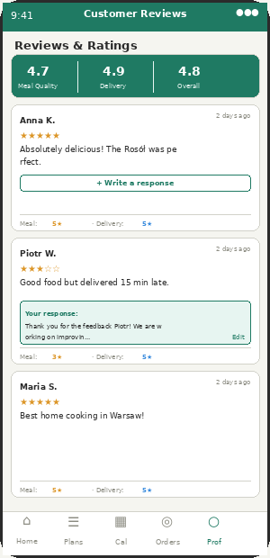
VM-09 — Customer reviews with vendor response capability

Aspect | Detail | What Appzeto Builds
Reviews list in VM-09 | VM-09 Analytics tab shows customer reviews. Each review: customer alias, star ratings (meal/delivery/overall separately), text comment, date. Vendor sees meal quality rating only (not delivery rating). | GET /api/vendors/{id}/reviews — returns reviews with ratings. delivery_experience rating hidden from vendor. Only meal_quality and overall shown.
Write a response | Below each review with no response yet: "+ Write a response" button. Tapping opens text input (max 280 chars). Vendor submits → response saved → shown publicly below review. | review.vendor_response: {text, created_at}. Once submitted: edit allowed for 24h. Cannot delete own response (only admin can delete).
Response visible to customer | In CA-13 Orders: customer can see vendor response below their review. Encourages accountability and quality improvement. | CA-13 order detail: show review + vendor_response if exists. Customer notified via push: "[Vendor] responded to your review."
Admin can moderate | AP-05 vendor profile: admin can hide or delete a vendor response if inappropriate. Requires reason logged. | admin_response_hidden: boolean. Reason logged in audit trail.
Response stats in AP-05 | Admin sees: response rate per vendor (what % of reviews they respond to). Useful quality metric. | vendor.review_response_rate = responded_count / total_reviews. Shown in AP-05 vendor profile.

GAP E — Live Stock Tracking for Vendors
Screen: VM-07 Meal Management + VM-NEW-01 Forecast Priority: P1 Add to: Part 2 + 4
Aspect | Detail | What Appzeto Builds
Vendor sets available portions | Already partially in PRD (capacity cap). Enhancement: as vendor prepares, they mark portions as "used." Running countdown shown on dashboard. | meal.available_today: int. meal.prepared_count: int (vendor increments as they cook). Remaining = available_today - prepared_count.
Low stock alert | When remaining portions < 20% of day's availability: amber alert on VM-03 dashboard. "Only 3 Rosół portions left — accept more orders?" | CRON every 15 min: if prepared_count/available_today > 0.8: push to vendor + alert in AP-11.
Auto-close when sold out | When prepared_count reaches available_today: meal auto-closes for new orders. Customer sees "Sold out" badge in CA-09. Admin sees in AP-11. | When sold out: meal.status_today = sold_out. CA-09 shows sold out badge. Cannot be ordered.
Admin low stock report (AP-11) | City Manager sees: which vendors are running low across all zones today. "Maria's Kitchen: 3 Rosół portions left. Bistro Centrum: 8 portions remaining." | AP-11 new card: "Today's Stock Status" — sorted by % remaining ascending.

GAP M — Pre-Order for New Meal Launches
Screen: VM-06 Menu + CA-09 Plans Priority: P2 Add to: Parts 1 + 2
Aspect | Detail | What Appzeto Builds
Vendor creates pre-order meal | In VM-07 Add Meal: new status option "Pre-order." Set launch date. Customer can reserve from now until launch date cutoff. | meal.status: active|draft|pre_order. meal.launch_date. meal.preorder_cutoff (defaults to launch_date - 1 day).
Customer sees pre-order badge | CA-09 Plans: meal card shows "Pre-order — launching Monday" badge in blue. Tap to reserve. No payment until launch day. | CA-09: pre_order badge (blue). Tap: "Reserve your portion — you'll be charged on [launch_date]." One-tap reserve.
Launch day processing | On launch_date: all pre-orders convert to confirmed orders. Payments processed. Vendor sees full pre-order demand in VM-NEW-01 forecast. | CRON at launch_date 00:01: pre_order → order. Payment processed. Vendor forecast updated.

GAP P — Return / Unsold Pantry Stock Tracking
Screen: VM-04 Orders + DA-07 Failed Delivery Priority: P1 Add to: Parts 2 + 3
Aspect | Detail | What Appzeto Builds
Failed pantry delivery disposition | When driver marks pantry delivery as failed (DA-07): new option "Returned to shop" added alongside existing options. Driver marks which bag was returned. | DA-07 box_disposition options: held_by_driver|returned_to_vendor|left_with_neighbour|returned_to_shop. shop_return triggers stock update.
Shop partner receives returned stock | When pantry item marked "returned to shop": shop partner sees in FP-03/VM-04 that item is being returned. They can restock it. | pantry_order.return_status: returned_to_shop. shop_partner notification: "1 bag returned by driver Jan W. Items: bread x1, milk x1."
Return tracking report (AP-11) | Weekly report: which pantry items are most returned. Helps admin advise shop partners to reduce order quantities for unpopular items. | pantry_return_report: item_name, return_count, return_rate%. Downloadable CSV.

PART 3 — Driver App — Part 3
3 new items in this section

GAP B Driver Attendance Tracking [P0]
GAP P Return Pantry Stock Disposition [P1]
GAP Z Driver Availability Confirmation 24h Before Shift [P1]

GAP B — Driver Attendance Tracking
Screen: DA-11 Shift Schedule + AP-06 Admin Priority: P0 Add to: Parts 3 + 4
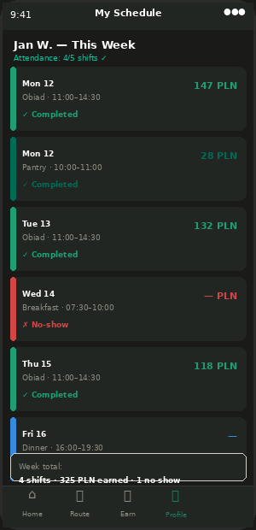
DA-11 — Shift schedule with attendance record (dark theme)

Aspect | Detail | What Appzeto Builds
Driver confirms availability (24h before) | DA-11 Shift Schedule shows upcoming shifts. Driver taps "Confirm Available" for each shift 24-48 hours before. If not confirmed by 2 hours before shift: admin alerted. | shift.availability_confirmed: boolean. Confirmed via DA-11. CRON 2h before shift: if not confirmed → alert City Manager.
No-show detection | If driver does not go online within 15 minutes of shift start: automatic no-show flag. Admin alerted immediately. | CRON at shift_start + 15min: if driver.is_online = false → shift.status = no_show. Alert City Manager + Fleet Manager.
Attendance record in DA-11 | Each past shift shown with status: Completed ✓ / No-show ✗ / Upcoming ⏳. Earnings shown for completed shifts. No-shows shown in red. | shift_records collection: {driver_id, date, shift_type, status, earnings, checked_in_at, checked_out_at}
Admin view in AP-06 | Driver profile in AP-06 shows: attendance rate this month (e.g. 18/20 shifts = 90%). City Manager can filter driver table by attendance rate. | driver.attendance_rate = completed_shifts / assigned_shifts * 100. Shown in AP-06 driver profile. Filter: attendance < 80% flags driver.
Fleet Partner visibility | Fleet partner sees attendance rate per driver in FP-01. Used to manage their own driver workforce. | FP-01 roster: attendance rate column. Fleet partner can see which of their drivers have low attendance.
No-show impact on minimum guarantee | If driver marked as no-show: minimum guarantee does NOT apply for that shift. Only applies to completed shifts. | min_guarantee only credited if shift.status = completed AND driver.deliveries_today >= minimum_threshold.

GAP Z — Driver Availability Confirmation 24h Before Shift
Screen: DA-11 Shift Schedule Priority: P1 Add to: Part 3
Aspect | Detail | What Appzeto Builds
How it works | DA-11 shows next 7 days of scheduled shifts. Each future shift has "Confirm ✓" button. Driver confirms they will show up. System tracks who has confirmed and who has not. | shift.availability_confirmed: boolean. Default false. Driver taps Confirm → true. Cannot unconfirm within 2h of shift start.
Push reminder | 24 hours before each shift: push notification to driver. "Your Lunch shift starts tomorrow at 11:00. Confirm you're available →" | FCM at shift_start - 24h: "Confirm your shift tomorrow." Deep link to DA-11.
Admin sees confirmation status | AP-06 driver management: tomorrow's shifts tab shows which drivers have confirmed and which have not. City Manager can call unconfirmed drivers. | AP-06 new view: "Tomorrow's Shifts" — driver name + shift + confirmed (green ✓) or not confirmed (amber ⚠).

PART 4 — Admin Panel — Part 4
11 new items in this section

GAP A Dynamic Slot Management — Admin Side [P0]
GAP B Driver Attendance in Admin (AP-06) [P0]
GAP F Bad Debt Customer Report (AP-11) [P1]
GAP G Business Holiday / Platform Closure (AP-08) [P1]
GAP H Google Analytics Integration (AP-09) [P1]
GAP I Mailchimp Integration (AP-09) [P1]
GAP K Zone-Based Delivery Pricing (AP-08) [P2]
GAP N Data Encryption Documented [P0]
GAP O Information Visibility Controls (AP-03) [P1]
GAP T Vendor Review Response Management (AP-05) [P1]
GAP Y Customer Group / Segment Allocation (AP-11) [P2]

GAP A — Admin — Dynamic Slot Management — Admin Panel
Screen: AP-08 City + Zone Management Priority: P0 Add to: Part 4
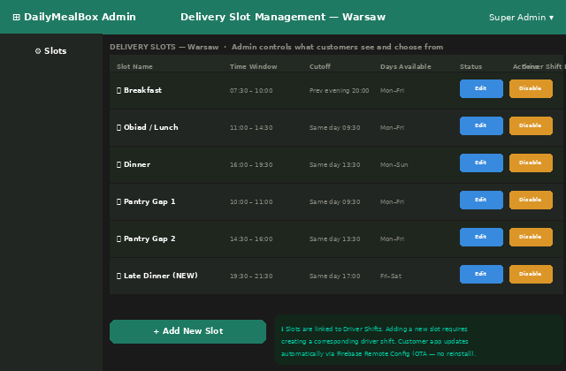
AP-08 — Dynamic Delivery Slot Management — admin adds/removes/edits slots

Aspect | Detail | What Appzeto Builds
Slot management screen | New section in AP-08 City Management: "Delivery Slots." Shows all configured slots per city as a table. Columns: name, time window, cutoff, days, status, linked driver shift, actions. | slot_types collection per city. Admin CRUD operations. Changes OTA via Remote Config → customer CA-05 updates within 15 min.
Add new slot | Admin clicks "Add New Slot." Form: slot name (e.g. "Late Dinner"), start time, end time, cutoff time, available days, city, linked driver shift. System warns if no driver shift exists for selected time. | POST /api/admin/slots. Validates: linked_shift_type must be an active shift. Creates slot as Draft first. Admin activates manually.
Deactivate slot | Admin deactivates a slot. System shows: "X active subscribers on this slot." Admin sends migration notification: "Your slot is being discontinued — please choose a new slot." | slot.status = deactivating. Grace period: 14 days. After grace: force-move subscribers to default slot. Logged in audit trail.
Slot linked to driver shift | One-to-one link. Cannot deactivate a driver shift if a slot is linked to it. Cannot create slot without linking to a shift. | Referential integrity enforced in backend. slot.linked_shift_id = shift._id. Cascade validation on shift deactivation.

GAP G — Business Holiday / Platform Closure Planning
Screen: AP-08 City Management Priority: P1 Add to: Part 4
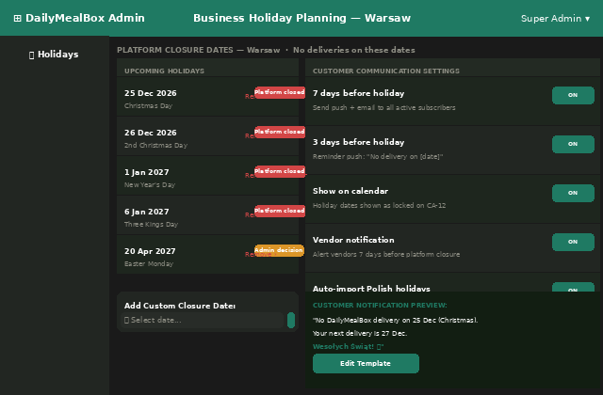
AP-08 — Business Holiday Planning with auto-import of Polish public holidays

Aspect | Detail | What Appzeto Builds
Holiday list per city | Admin adds no-delivery dates per city. Polish public holidays auto-imported annually (Polish government API or hardcoded list). Admin can add custom closure dates. | platform_holidays collection: {date, name, city, scope: all|city, auto_imported: boolean, status: confirmed|pending}
Auto-import Polish holidays | System imports official Polish public holidays at start of each year. Admin reviews and confirms. Cannot be auto-applied without admin confirmation. | Hardcoded list + admin review flow. Admin sees "Import 2027 Polish holidays (13 dates)" button in January.
Customer communication | 7 days before: push + email to all active subscribers. 3 days before: reminder push. Holiday dates shown as special locked days on CA-12 calendar (different icon from normal cutoff lock). | FCM + email template: "No DailyMealBox delivery on [date] ([holiday name]). Next delivery: [date]." CA-12: holiday locked day = 🎄 or 🐣 icon.
Vendor and driver notification | Vendors notified 7 days before via push + email. Drivers notified 7 days before — shift marked as "Platform Holiday — no shift." | Vendor FCM: "Platform closed [date]. No orders will be placed." Driver DA-11: shift shows "Platform Holiday" instead of shift details.

GAP O — Information Visibility Controls Per User Type
Screen: AP-03 Feature Toggles — new category Priority: P1 Add to: All Parts
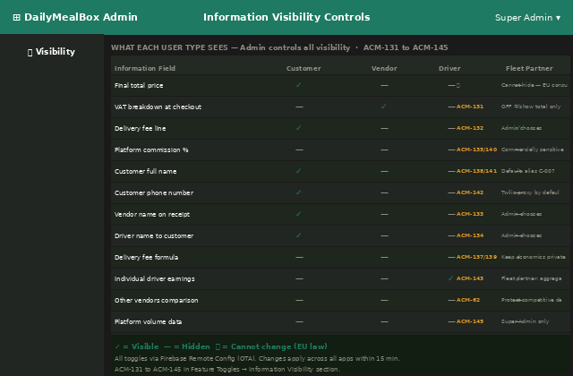
AP-03 — Information Visibility Matrix — admin controls what each user type sees

FULL SPEC: Full specification in previous session. Summary: Admin controls 15 visibility toggles (ACM-131 to ACM-145) determining what each user type sees about VAT, fees, commissions, customer identity, and pricing. Some cannot be hidden (EU law). All OTA via Firebase Remote Config.
Aspect | Detail | What Appzeto Builds
New AP-03 section | AP-03 Feature Toggles gets new accordion: "Information Visibility." Contains the 15 ACM controls as a matrix view showing Customer/Vendor/Driver/Fleet columns with ON/OFF toggles per row. | New feature_group: information_visibility. 15 toggle rows. Visual matrix layout — admin sees all at once.
EU law locks | Certain fields cannot be hidden: final customer price, B2B VAT invoice breakdown, B2C receipt total, GDPR notice. These show lock icons in the matrix. Admin cannot toggle them. | toggle.eu_law_locked: boolean. If true: rendered as read-only with lock icon and EU law citation shown on hover.
OTA propagation | All 15 visibility controls delivered via Firebase Remote Config. Apps fetch on open. Changes apply within 15 min across all platforms without reinstall. | Each ACM maps to a Remote Config parameter. On change: apps re-render affected sections.

GAP F — Bad Debt Customer Report
Screen: AP-11 Analytics Priority: P1 Add to: Part 4
Aspect | Detail | What Appzeto Builds
Bad debt definition | Customer flagged as bad debt if: 3+ payment failures in 90 days OR 3+ refund requests in 60 days OR 1 disputed chargeback. | CRON daily: check payment_attempts and refunds per customer. Flag if thresholds exceeded.
Report in AP-11 | New report tab: "Bad Debt Customers." Table: customer alias, failure count, refund count, total debt amount, last active date, recommended action. | AP-11 new section. City Manager sees their city only. Super Admin sees all cities.
Actions per customer | CS can: add customer note (internal), set COD block (no more COD orders), set subscription block (cannot start new subscription), or escalate to Super Admin. | customer.bad_debt_flags: {cod_blocked, subscription_blocked, flagged_by, flagged_at, notes}

GAP H+I — Google Analytics + Mailchimp Integrations
Screen: AP-09 API Settings Priority: P1 Add to: Part 4
Aspect | Detail | What Appzeto Builds
Google Analytics (Gap H) | GA4 measurement ID configurable by Web Manager in AP-09. Tracks web version: page views, subscription starts, checkout drop-offs, slot selection events. | ga4_measurement_id stored in AP-09. Injected into web app <head> via Remote Config. Event tracking: subscription_started, checkout_began, slot_selected.
Mailchimp (Gap I) | Mailchimp API key + audience ID configurable by Marketing Manager in AP-09. Syncs customer email segments: active_subscribers, churned, trial_users. GDPR: only opted-in emails synced. | mailchimp_api_key in AP-09. CRON daily: sync opted-in customer emails to Mailchimp lists. Segment tags: active, churned, trial, b2b.
Opt-in requirement (GDPR) | Only customers who opted in to marketing emails are synced to Mailchimp. Default: opted-out. Customer opts in via CA-15 Notification Settings. | user.marketing_email_consent: boolean. Default false. Only true = synced to Mailchimp. Logged with timestamp for GDPR compliance.

GAP N — Data Encryption — Explicitly Documented
Screen: AP-09 API Settings + Technical Spec Priority: P0 Add to: Part 4
EU LAW — GDPR ARTICLE 32: GDPR Article 32 requires appropriate technical measures including encryption. This was never stated explicitly in the PRD. Appzeto must implement and document their encryption approach.
Aspect | Detail | What Appzeto Builds
In transit | ALL data transmitted between apps and backend: TLS 1.3 minimum. No HTTP — all HTTPS. WebSocket connections: WSS (WebSocket Secure). Google Maps API calls: HTTPS only. | Appzeto must configure TLS 1.3 on all endpoints. HTTP → HTTPS redirect enforced. WSS not WS for Socket.io.
At rest | MongoDB data encrypted at rest using AES-256 (MongoDB Atlas Encryption at Rest, or equivalent). Firebase Storage: encrypted by default. Google Drive: encrypted by Google. | MongoDB Atlas: enable Encryption at Rest. Key management: AWS KMS or MongoDB-managed. Confirm in writing before launch.
PII field-level encryption | Extra layer for sensitive PII fields: customer phone, email, address, payment method last4. Encrypted individually in MongoDB — even DB admin cannot read in plaintext. | Fields to encrypt: user.phone, user.email, user.addresses[], user.payment_methods[]. Application-level encryption using AES-256 before storing.
Driver documents | Driving licence, national ID, vehicle registration — stored on Google Drive with restricted access. Not public URLs. Access via service account token with expiry. | Google Drive files: visibility = restricted. Access via server-side token generation with 1-hour expiry. Never expose permanent file URL.
Appzeto must document | Before launch: Appzeto submits a Security Architecture document confirming all encryption implementations. DailyMealBox reviews and approves before Production environment is activated. | Deliverable from Appzeto: Security_Architecture_v1.pdf covering all encryption implementations, key management, and access controls.

New ACM Controls — ACM-146 to ACM-160

ADD TO ADMIN CONTROLS MATRIX: 15 new admin controls added by Amendment v2. Add these to Admin Controls Matrix v2.1. Running total is now 160 controls across all 5 apps.
ACM# | Feature | Who Can Change | Default | Notes
146 | Dynamic delivery slot — enable custom day selection | Super Admin | Disabled | Customer picks specific days Mon/Wed/Fri etc. instead of Mon-Fri preset.
147 | Dynamic delivery slot — enable per-day different slots | Super Admin | Disabled | Customer assigns different slot to each delivery day. E.g. Lunch Mon/Wed, Dinner Tue/Thu.
148 | Maximum slots per customer per day | Super Admin | 1 slot/day | Admin sets how many concurrent slots per day customer can subscribe to.
149 | Annual subscription plan — enable/disable | Super Admin | Disabled | Adds 12-month plan at checkout. Admin sets annual discount % (default 2 months free).
150 | Discounted trial / free first week — enable/disable | Super Admin, Marketing | Disabled | New customer trial offer. Admin sets discount % and minimum order before trial applies.
151 | Fortnightly delivery option — enable/disable | Super Admin | Disabled | Every 2 weeks delivery option. Admin enables per city.
152 | Driver attendance confirmation (24h before shift) | Super Admin, City Manager | Disabled | Drivers must confirm availability 24h before shift. Admin alerted if not confirmed 2h before.
153 | Business holiday auto-import (Polish public holidays) | Super Admin | Enabled | Auto-imports official Polish public holidays annually. Admin reviews before applying.
154 | Google Analytics 4 integration | Super Admin, Web Manager | Disabled | GA4 measurement ID configurable from AP-09. Applies to web version customer app.
155 | Mailchimp email marketing sync | Super Admin, Marketing Manager | Disabled | Mailchimp API key + audience sync. GDPR: opted-in customers only.
156 | WhatsApp invoice delivery | Super Admin | Disabled | Customer can choose WhatsApp as invoice delivery method in CA-v2-07 preferences.
157 | Zone-based delivery pricing override | Super Admin, City Manager | Disabled | Different delivery fee per zone within same city. City Manager sets per zone.
158 | Vendor response to reviews — enable/disable | Super Admin, City Manager | Enabled | Vendors can respond to customer meal quality reviews from VM-09.
159 | Separate meal/delivery/overall rating display | Super Admin | Enabled | Show three separate rating categories to customer after delivery. If disabled: single overall rating only.
160 | Customer segment / group allocation | Super Admin, Marketing Manager | Disabled | Admin assigns customers to named segments (e.g. "B2B", "Power User", "Trial"). Used for targeted campaigns.

Complete Amendment History — All Versions

COMPLETE HISTORY: This table shows every amendment ever made to the DailyMealBox PRDs. After Amendment v2 is added, the product specification is complete. No further amendments expected before development starts.
Amendment | Items | What it Covered | ACM Range
Amendment v2 | 18 items | Missing features from original scope: Collection PIN, Delivery PIN, GDPR deletion, cookie consent, legal pages, credit notes, payment failure flow, driver invitation, fleet staff accounts, multi-language notifications, rating rules | ACM-1 to ACM-122 (existing)
Amendment v2 | 8 items | Organic Pantry Box: 5-shift model, Shop Partner 5th vendor type, pantry customer tab, pantry driver shifts, admin shop management, 8 new push notifications, MongoDB schemas | ACM-123 to ACM-130
Competitor gap audit | 15 items | Features in live competitor app not in PRD: driver attendance, annual plan, discounted trial, live stock tracking, bad debt report, holiday planning, Google Analytics, Mailchimp, WhatsApp invoicing, zone pricing, return stock tracking | ACM-131 to ACM-145
Information visibility | 15 ACM controls | Admin controls what each user type sees: VAT, fees, commission, customer identity, pricing across all 5 apps | ACM-131 to ACM-145 (shared with above)
Amendment v2 (this doc) | 26 items + 11 screens | Dynamic slot system, driver attendance, subscription upgrade flow, address validation, multiple addresses, split ratings, vendor review responses, custom days, notification preferences, data encryption, business holidays, Analytics, Mailchimp, WhatsApp invoicing | ACM-146 to ACM-160
TOTAL | 82+ items across all amendments | Complete product specification — all gaps closed | ACM-1 to ACM-160 (160 total controls)
DailyMealBox — Amendment v2 (Final) · 10 June 2026 · 26 items · 11 new screens · ACM-146 to ACM-160 · 160 total controls · dailymealbox.com

ADDENDUM — QOOX RESEARCH · HOME COOK LEGAL MODEL
Added 11 June 2026 · Research source: qoox.pl (live Polish competitor) · Gap AA — Two-Track Home Cook Onboarding

RESEARCH FINDING: Qoox.pl is a live Polish platform allowing home cooks to sell food online. Research of their legal model reveals that DailyMealBox's current Kitchen Partner approach (requiring a Sp. z o.o. company) is too complex for small-volume home cooks just starting out. Polish and EU law already permits home cooking sales under a simpler registration path. This addendum defines a Two-Track Home Cook Onboarding model that makes DailyMealBox accessible to ALL home cooks — not just those who already have or can afford a company structure.
The Legal Framework — How Home Cooking Sales Are Legal in Poland

LEGAL BASIS: Polish and EU law EXPLICITLY permits home food production and sales under specific conditions. The legal basis: (1) EU Regulation EC No 852/2004 on hygiene of foodstuffs — provides flexible approach for small-scale home production. (2) Polish Act of 25 August 2006 on food and nutrition safety. No law requires a home cook to convert their kitchen into a restaurant. They only need Sanepid registration.
What a Home Cook Needs to Operate Legally
Aspect | Detail | What Appzeto Builds
Sanepid registration | Register kitchen with local Powiatowa Stacja Sanitarno-Epidemiologiczna (County Sanitary and Epidemiological Station). No inspection required before starting — but Sanepid may visit. Takes 2–4 weeks. | DailyMealBox provides checklist in VM-02 app. Partner with a local Sanepid consultant to guide vendors through registration. Offer this service free as a vendor acquisition tool.
Kitchen physical requirements | Clean, organised kitchen separated from living area. Access to drinking water. 3 water points: handwashing sink, equipment sink, food washing sink. 2 refrigerators (business separate from personal). Functional ventilation. Oven, stove, work surfaces. | DailyMealBox vendor checklist in VM-02: photo upload of kitchen. Admin reviews kitchen photos before approving home cook. Not a full Sanepid inspection — just a basic quality check.
HACCP / GMP / GHP documentation | Home cook must implement Good Manufacturing Practice (GMP) and Good Hygiene Practice (GHP). For small-scale production, HACCP plan can be simplified. Sanepid accepts basic documentation. | DailyMealBox provides: downloadable GMP/GHP template in vendor app (PDF). Pre-filled template that cook completes with their specific kitchen details. Reduces admin burden to minimum.
Działalność nierejestrowana threshold | If monthly income from food sales does not exceed 75% of minimum gross salary (3,499.50 PLN in 2025): NO company registration needed. No ZUS contributions. No accountant. Just file personal income tax annually. | DailyMealBox tracks each home cook's monthly earnings from platform. When cook approaches threshold: automatic warning in vendor app "You are approaching the unregistered activity limit. Consider registering your business."
Above the threshold | Once cook earns above 3,499.50 PLN/month consistently: must register CEIDG (sole trader) or company. ZUS contributions begin. Income tax changes. | DailyMealBox offers Track 2 at this point: Kitchen Partner model OR the cook registers their own CEIDG and continues as a registered vendor.

Gap AA — Two-Track Home Cook Onboarding Model

CURRENT GAP: The current DailyMealBox PRD assumes ALL home cooks use the Kitchen Partner model (linking to a Sp. z o.o. company). This is correct for high-volume cooks but creates unnecessary friction for small-volume cooks just starting. Qoox research reveals a simpler, faster, legally valid path for beginners. This addendum defines Two Tracks.
Track 1 vs Track 2 — Side by Side Comparison
Aspect | TRACK 1 — Starter Cook  (Działalność Nierejestrowana) | TRACK 2 — Established Cook  (Kitchen Partner / Own Company)
Monthly earnings limit | Under 3,499.50 PLN/month from DailyMealBox  (75% of 2025 minimum gross wage) | No limit — can earn any amount
Company registration | NONE required  Personal income only | Kitchen Partner Sp. z o.o.  OR own CEIDG sole trader registration
ZUS (social insurance) | NOT required  Significant cost saving for starter cooks | Required — handled by Kitchen Partner  OR paid by cook directly
Invoicing | DailyMealBox issues invoices on cook's behalf  (platform acts as intermediary) | Kitchen Partner Sp. z o.o. issues invoices  OR cook's own company invoices
VAT on food sales | Not VAT registered  Cook below VAT threshold  (200,000 PLN/year) | Kitchen Partner handles VAT  OR cook registers for VAT when needed
Income tax | Cook declares income annually  Personal income tax (PIT)  18% or 32% threshold | Kitchen Partner handles tax  OR cook files own business taxes
Sanepid registration | REQUIRED — same for both tracks  Kitchen inspection registration  2–4 weeks process | REQUIRED — same for both tracks  May need additional food business licence  if handling large volumes
Time to go live on DailyMealBox | 2–4 weeks  (mainly waiting for Sanepid registration) | 4–8 weeks  (Sanepid + company setup + Kitchen Partner onboarding)
DailyMealBox commission | 15% (Home Cook rate)  Same as Track 2 | 15% (Home Cook rate)  Kitchen Partner keeps 15% of that  Cook receives 85% net
Best for | New home cooks testing the platform  Part-time cooking income  Cooks earning < 3,500 PLN/month | Full-time home cook business  Cooks earning > 3,500 PLN/month  Cooks wanting professional setup
DailyMealBox support | Free Sanepid checklist in app  GMP/GHP template download  Monthly earnings tracker with threshold warning | Kitchen Partner introduction and contract  Full legal and accounting support via KP  Higher platform support tier

What to Add to Each PRD Part

Add to Part 2 — Vendor App (VM-02 Registration)
VM-02 Registration currently asks vendor to select one of 4 vendor types: Home Cook / Cloud Kitchen / Restaurant / Catering. Home Cooks must now be asked which track they are on. This determines what documents they upload and what support they receive.
Aspect | Detail | What Appzeto Builds
New VM-02 step for Home Cook type | After selecting Home Cook as vendor type: new screen appears asking "How are you set up?" with two options as large cards. | VM-02 new sub-step: track_selection screen shown only when vendor_type = home_cook. Two card options below.
Card 1 — Track 1: I'm just starting | "I cook at home, no company yet. I earn under 3,500 PLN/month from cooking." → Lead through Sanepid checklist and GMP/GHP template download. Upload: kitchen photos (front + main workspace) + Sanepid registration document (can submit after getting it). | vendor.cook_track = 1. Documents required: kitchen_photos (2 minimum), sanepid_registration_url (can be pending at signup — give 30 days to upload). kitchen_partner_id = null.
Card 2 — Track 2: I have a company / Kitchen Partner | "I have a registered business or I want to link to a Kitchen Partner." → Standard Kitchen Partner flow as currently documented. Upload: organic certification / food licence / company docs. | vendor.cook_track = 2. If kitchen_partner_id set: all invoicing via Kitchen Partner. If own company: vendor.company_nip required.
Sanepid checklist inside app | Track 1 cooks see a Sanepid registration checklist in their VM-02 flow: 8-step guide with photos of what is required. Downloadable PDF. Link to local Sanepid offices by city. | Static content — no backend needed. PDF stored in Firebase Storage, served from vendor app. Web Manager updates content via AP-13 OTA.
GMP/GHP template download | Track 1 cooks download a pre-filled GMP/GHP documentation template (Polish language). They fill in their kitchen details and submit to Sanepid. | PDF template in Firebase Storage. Downloaded from VM-02 Track 1 flow. Also emailed to vendor automatically after track selection.
Monthly earnings tracker for Track 1 | VM-08 Earnings screen: Track 1 cooks see their monthly earnings with a progress bar toward the 3,499.50 PLN threshold. At 80%: amber warning. At 100%: red alert + guidance to upgrade to Track 2. | CRON monthly: sum vendor earnings for current month. If > 2,800 PLN (80%): push "You are approaching the unregistered activity limit." If > 3,499: red alert + link to Kitchen Partner or CEIDG registration guide.

Add to Part 4 — Admin Panel (AP-05 Vendor Management)
Admin Panel must show cook track for each home cook vendor, and alert City Manager when a Track 1 cook approaches the earnings threshold.
Aspect | Detail | What Appzeto Builds
Track badge in AP-05 vendor table | Home Cook vendors show a track badge in the vendor table: "Track 1" (orange badge) or "Track 2" (green badge). City Manager can see at a glance which cooks are on which track. | vendor.cook_track field displayed as badge in AP-05 table. Filter option: Track 1 / Track 2 / All Home Cooks.
Threshold alert in AP-01 dashboard | When Track 1 cook's monthly earnings reach 3,000 PLN (approaching 3,499 limit): AP-01 alert. "Track 1 cook Maria K. earning 3,100 PLN this month — approaching unregistered activity limit." | CRON daily: check all vendor.cook_track = 1 vendors. If monthly_earnings > 3000: insert alert into admin_alerts. City Manager sees in AP-01 alerts panel.
Upgrade prompt to cook | When cook crosses threshold: City Manager contacts them to upgrade. Admin sends in-app message from AP-05 vendor profile: "Your earnings have exceeded the threshold. Please upgrade to Track 2 or register your business within 30 days." | AP-05: "Send Track Upgrade Notice" button on vendor profile. Sends FCM + email template to cook. 30-day grace period before account review.
Document compliance per track | Admin can see at a glance which Track 1 cooks have uploaded: kitchen photos ✓, Sanepid registration ✓. Red flag if Sanepid doc not uploaded within 30 days of joining. | vendor.documents checklist per track. AP-05 vendor profile: document status row for each required doc. Color: green (uploaded), amber (pending), red (overdue).

New ACM Controls from This Addendum — ACM-161 to ACM-165

ACM# | Feature | Who Can Change | Default | Notes
161 | Home Cook track selection — enable Track 1 (unregistered activity) per city | Super Admin | Enabled (Warsaw launch) | When OFF: all home cooks must use Track 2 (Kitchen Partner or own company). Use if city regulations change or if Sanepid requirements tighten.
162 | Track 1 monthly earnings threshold warning level | Super Admin | 80% of legal threshold  (2,799 PLN in 2025) | Amber warning in vendor app when cook approaches unregistered activity limit. Admin can adjust warning level as government threshold changes annually.
163 | Sanepid registration grace period for Track 1 cooks | Super Admin, City Manager | 30 days | Track 1 cooks can join platform and start receiving orders before Sanepid doc uploaded. Grace period: 30 days. After: account paused until doc uploaded.
164 | GMP/GHP template — language and version control | Super Admin, Web Manager | Polish — latest version | GMP/GHP template PDF served from Firebase Storage. Web Manager updates content via AP-13 when regulations change. OTA — no reinstall.
165 | Kitchen photo review — required before home cook goes live | City Manager, Super Admin | Required (2 photos minimum) | Admin reviews kitchen photos before approving Track 1 home cook. Not a Sanepid inspection — basic quality and hygiene check only.

ADDENDUM 2 — SETTLEMENT, LEGAL CMS & FLEXIBLE FLEET PARTNER
Added 13 June 2026 · Gaps AB, AC, AD · ACM-166 to ACM-170 · 3 new screens

WHY THIS ADDENDUM: Three follow-up items from the Two-Track Home Cook model (Gap AA): (1) How does DailyMealBox settle accounts and produce invoices when a Track 1 home cook has no business/VAT registration to issue against? (2) Legal documents (Terms of Sale, Privacy Policy, Cook Agreements) must collect the right declarations from Track 1 cooks and be editable from the Admin Panel without redeploying the apps. (3) Any home cook — Track 1 or Track 2 — should be able to nominate their own trusted delivery partner, subject to admin approval, with the platform pool as fallback.
Gap AB — Settlement Statements for Track 1 Home Cooks

THE PROBLEM: A Track 1 home cook operates under działalność nierejestrowana — they have no NIP for business invoicing and are not VAT registered. They CANNOT issue an invoice to DailyMealBox, and DailyMealBox cannot ask them to. Yet DailyMealBox still owes them money every week and needs a paper trail for its own accounting AND for the cook's annual personal income tax (PIT) declaration.
THE SOLUTION — SELF-BILLING (already a precedent in our model): DailyMealBox already self-invoices on behalf of vendors and fleet partners (documented in the Fleet Partner Research — "Vendor Invoice to Platform — DailyMealBox self-invoicing on vendor's behalf"). The same mechanism extends to Track 1 cooks: DailyMealBox generates a monthly SETTLEMENT STATEMENT ("Rozliczenie") on the cook's behalf. It is NOT a VAT invoice — no VAT is charged or claimed — it is a record of gross earnings, commission deducted, and net amount paid, for the cook's own personal tax records.
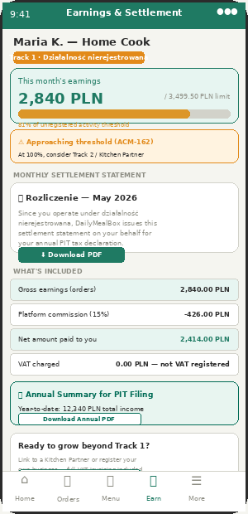
VM-08 — Track 1 cook earnings with monthly Settlement Statement (Rozliczenie)

Aspect | Detail | What Appzeto Builds
Customer-facing invoices — UNCHANGED | B2C receipts and B2B VAT invoices are ALWAYS issued by DailyMealBox Sp. z o.o. This was already true before Track 1 existed and does not change. The customer never sees whether the cook is Track 1 or Track 2, and never sees a cook NIP (because Track 1 cooks don't have one). | No change to CA-v2-01 / CA-v2-02 invoice templates. Optional credit line "Prepared by [Cook First Name]" controlled by existing ACM-133 (show/hide vendor name on receipt).
Monthly Settlement Statement (Rozliczenie) | For Track 1 cooks only: generated automatically on the 1st of each month for the previous month. Shows: gross earnings (sum of order values), platform commission deducted (15%), net amount paid. States explicitly "No VAT — seller not VAT-registered (działalność nierejestrowana)." | New collection: cook_settlements {vendor_id, period, gross_pln, commission_pln, net_pln, vat_amount: 0, generated_at, pdf_url}. CRON 1st of month at 06:00, same job family as B2B invoice generation (CA-v2-02 cron).
Where the cook sees it | VM-08 Earnings & Wallet screen, new card "Monthly Settlement Statement" with Download PDF button. Visible only if vendor.cook_track == 1. | VM-08 conditional render on cook_track field. PDF stored in Firebase Storage under /settlements/{vendor_id}/{year}-{month}.pdf, same retention pattern as invoices (kept while account active + 5 years after, for PIT audit window).
Annual summary for PIT filing | On request (or auto-generated each January for the prior year): one PDF summing all 12 monthly settlements into an annual total. Cook attaches this to their PIT-36/PIT-37 personal tax return as supporting evidence of income from "działalność nierejestrowana" or "inne źródła" (other sources). | annual_settlement_pdf generated from the 12 cook_settlements records for that year. "Download Annual PDF" button in VM-08. No new collection — derived report.
Threshold linkage (ties to ACM-162) | The monthly settlement is also the data source for the threshold monitor from Gap AA. The same gross_pln figure that appears on the Rozliczenie is what gets compared against the 3,499.50 PLN limit. | cook_settlements.gross_pln (current month, running total) feeds the ACM-162 threshold check. One source of truth — no duplicate calculation.
What happens at Track 2 upgrade | Once a cook upgrades to Track 2 (Kitchen Partner or own CEIDG/company), settlement statements stop and standard B2B/vendor invoicing via Kitchen Partner begins, exactly as already documented in the original Kitchen Partner model. | vendor.cook_track: 1→2 transition date stored. cook_settlements stop generating from that date. Existing Kitchen Partner invoice flow takes over with no further changes.

Gap AC — Legal Document Management from Admin Panel

WHY THIS IS NEEDED NOW: Track 1 introduces a new legal relationship (Cook Agreement covering działalność nierejestrowana declarations, Sanepid responsibilities, and the self-billing/settlement mechanism). Terms of Sale and Privacy Policy must also be updated to describe how Track 1 cooks appear on the platform and how their data is processed. None of this should require a developer or app release — it must be a CMS the Web Manager / Super Admin controls.
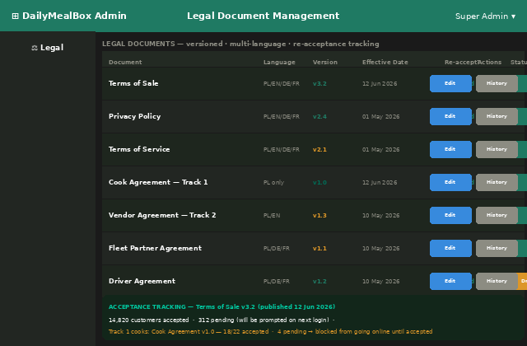
AP-13 (extended) — Legal Document Management: versioning, languages, and re-acceptance tracking

Aspect | Detail | What Appzeto Builds
New AP-13 section: "Legal Documents" | A table listing every legal document in the platform: Terms of Sale, Privacy Policy, Terms of Service, Cook Agreement (Track 1), Vendor Agreement (Track 2), Fleet Partner Agreement, Driver Agreement. Each row shows current version, languages available, effective date, whether re-acceptance is required, and publish status (Draft / Published). | New collection: legal_documents {doc_type, language, version, content_url or rich-text body, effective_date, requires_reacceptance: boolean, status: draft|published}. AP-13 CRUD UI. Web Manager + Super Admin roles only.
Versioning and edit history | Every edit creates a new version. Previous versions remain accessible ("History" button) for audit purposes — important because GDPR and consumer law require showing which terms a user agreed to at the time. | legal_document_versions collection — append-only. Never overwrite. "History" button opens read-only viewer of any past version with its effective dates.
Multi-language documents | Each document can have a version per active language (Polish, German, French, English at minimum). Customer/vendor sees the version matching their language preference; falls back to Polish (or English for international) if their language version is missing. | legal_documents keyed by (doc_type, language, version). App requests document for user.language_preference; backend falls back per existing i18n fallback pattern already used for push notifications.
Re-acceptance flow ("Required" toggle) | When a new version is published with "Requires re-acceptance" = ON, every affected user (customer / vendor / driver / fleet partner, depending on doc type) is shown a one-time acceptance screen on next login. They cannot proceed past it without accepting. Acceptance is logged with user ID, document version, and timestamp. | user_legal_acceptances collection: {user_id, doc_type, version, accepted_at}. App checks on login: does user have acceptance record for the currently published version of each requires_reacceptance doc relevant to their role? If not → blocking modal before app is usable.
Cook Agreement (Track 1) — specific content | New document type covering: cook confirms they operate under działalność nierejestrowana and are below the income threshold; cook authorises DailyMealBox to issue monthly Settlement Statements on their behalf (Gap AB); cook confirms Sanepid registration is in progress/complete; cook understands the 30-day grace period (ACM-163) and threshold monitoring (ACM-162). | doc_type: cook_agreement_track1. Shown during VM-02 Track 1 onboarding (Gap AA) as a mandatory acceptance step before the cook can submit their application. Same acceptance logging as above.
Acceptance dashboard | Bottom panel on the Legal Documents screen shows live counts: how many users have accepted the current version vs how many are pending. For Cook Agreement specifically: cooks who haven't accepted cannot go online (same enforcement style as document-expiry auto-suspend already used for food licences). | Aggregation query on user_legal_acceptances vs active user base per doc_type. For cook_agreement_track1: if no acceptance record AND cook_track==1 → driver/vendor app blocks "Go Online" / "Mark Ready" actions with prompt to accept.

Gap AD — Flexible / Preferred Fleet Partner per Home Cook

WHY THIS IS NEEDED: Many home cooks already have a trusted delivery arrangement — a family member with a scooter, a neighbour, or a small local courier they already use for pickup orders today. Forcing every cook onto the general platform driver pool removes a relationship they value and may be a barrier to joining DailyMealBox at all. The platform should allow ANY vendor (Track 1 or Track 2, any vendor type) to nominate a preferred fleet partner — subject to the same admin verification as any other fleet partner — while keeping the general driver pool as an automatic fallback.
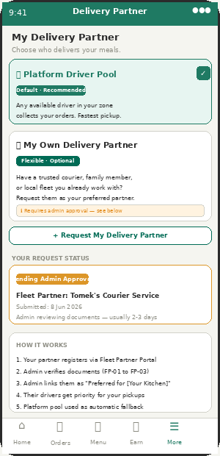
VM-12 — Vendor profile: choose platform pool or request own delivery partner

Aspect | Detail | What Appzeto Builds
New VM-12 "My Delivery Partner" section | Every vendor (any type, any track) sees two options: (1) Platform Driver Pool — default, any available zone driver collects their orders, or (2) My Own Delivery Partner — vendor names a fleet partner company or individual courier they already work with and requests them as preferred. | vendor.delivery_preference: pool | preferred_fleet_partner. vendor.preferred_fleet_partner_id: ObjectId (nullable). Defaults to pool — no change to existing behaviour unless vendor opts in.
Nominated partner must register normally | The nominated partner (whether an established fleet company or a single person with a scooter) goes through the SAME Fleet Partner Portal registration as any fleet partner (FP-01: company/individual details, NIP if applicable, bank IBAN, document upload). For a single courier without a company: same działalność nierejestrowana path as Track 1 cooks can apply to fleet partners too — DailyMealBox self-bills their delivery earnings the same way as Gap AB. | No new registration flow — reuse FP-01 to FP-03 exactly as documented. Add fleet_partner.entity_type: company | individual_unregistered. If individual_unregistered: delivery earnings settled via the same cook_settlements-style mechanism (renamed generically as partner_settlements) instead of an invoice.
Admin links partner to vendor | Once the nominated partner is approved through normal Fleet Partner verification (AP-06 / Fleet Manager document review), Super Admin or City Manager links them as "Preferred for [Vendor Name]" from the fleet partner's admin profile. This pairing is many-to-one: one fleet partner can be preferred for multiple vendors, but each vendor has at most one preferred partner at a time. | fleet_partner.preferred_for_vendor_ids: [ObjectId]. Set only by admin — never directly by vendor or fleet partner. Change logged in audit trail (who linked, when, previous pairing if any).
Routing priority — preferred partner first, pool as fallback | When the VRPTW route generator (DA-04 backend logic) assigns pickups for a vendor with a preferred fleet partner: it first checks whether a driver from that fleet partner is online and within the vendor's zone. If yes — prioritise them for that pickup. If no driver from the preferred partner is available: fall back to the general platform pool automatically, with no delay or manual intervention. | generateDailyRoute(): before pickup assignment, check vendor.preferred_fleet_partner_id. Filter available drivers for that pickup to fleet_partner_id == preferred first; if filtered set is empty, use full pool. Fallback is silent — vendor and customer experience unaffected.
Vendor sees request status in VM-12 | After requesting a preferred partner: VM-12 shows status — Pending Admin Approval / Approved (with partner name) / Rejected (with reason, can re-request). While pending or rejected, platform pool continues as normal — no disruption to deliveries. | fleet_request.status: pending|approved|rejected. Vendor notified via FCM on status change. Rejection requires reason (same pattern as vendor/driver rejection reasons elsewhere in the PRD).
Admin oversight (AP-05 / AP-06) | AP-05 vendor profile shows "Preferred Delivery Partner: [name or Platform Pool]" with a change/unlink button. AP-06 fleet partner profile shows list of vendors they are preferred for. Either side can be unlinked by admin at any time — reverts that vendor to platform pool immediately. | AP-05 and AP-06 read/write the same preferred_for_vendor_ids and preferred_fleet_partner_id fields. Unlink action: both fields cleared, logged in audit trail, vendor notified.

New ACM Controls from Addendum 2 — ACM-166 to ACM-170

ACM# | Feature | Who Can Change | Default | Notes
166 | Monthly Settlement Statement auto-generation for Track 1 cooks | Super Admin | Enabled — 1st of month, 06:00 | CRON job generating cook_settlements PDFs. Tied to ACM-162 threshold data. Disabling stops new statements but does not delete historical ones.
167 | Show "Prepared by [Cook Name]" credit line on customer receipts | Super Admin | OFF | Shares the same toggle family as ACM-133 (vendor name on receipt). When ON: first name only shown, never surname or business details.
168 | Legal document re-acceptance enforcement | Super Admin, Web Manager | Per-document — set when publishing | When a Web Manager publishes a new version with "Requires re-acceptance" checked, this is what triggers the blocking acceptance modal platform-wide for the relevant user group.
169 | Allow vendors to request a preferred fleet partner | Super Admin | Enabled | Master switch for Gap AD. If OFF: VM-12 "My Delivery Partner" section hidden entirely — all vendors use platform pool only.
170 | Preferred fleet partner routing priority | Super Admin, City Manager | Enabled — preferred first, pool fallback | If OFF: preferred_fleet_partner_id pairings remain stored but routing ignores them — useful for temporarily reverting to pure pool-based routing during high-demand periods without losing vendor preferences.

What to Confirm with Appzeto — Addendum 2

Priority | Item to Confirm | Detail
P0 | cook_settlements collection + monthly self-billing CRON for Track 1 cooks | Same job family as existing B2B invoice CRON (CA-v2-02). No VAT calculation — vat_amount always 0. PDF generated and stored, downloadable from VM-08. Annual summary PDF derived from 12 monthly records.
P0 | legal_documents + legal_document_versions + user_legal_acceptances collections | AP-13 CRUD UI for Web Manager/Super Admin. Versioning is append-only — never overwrite. Multi-language with Polish fallback. Blocking acceptance modal on login when requires_reacceptance is set and user has no record for current version.
P1 | Cook Agreement (Track 1) as mandatory acceptance step in VM-02 | New doc_type cook_agreement_track1. Shown during Track 1 onboarding (Gap AA) before submission. Enforcement: cook_track==1 vendor cannot go online without an acceptance record for current published version.
P1 | vendor.preferred_fleet_partner_id + routing priority logic | VM-12 new section (ACM-169 gated). Admin linking flow in AP-05/AP-06. VRPTW route generator checks preferred partner first, falls back to pool — fallback must be silent and automatic (ACM-170 gated).
P1 | fleet_partner.entity_type (company vs individual_unregistered) + partner_settlements for unregistered couriers | Reuses Gap AB self-billing mechanism, generalised. An individual courier nominated by a vendor can register without a company, exactly like a Track 1 cook, and receives the same style of settlement statement instead of an invoice.

FINAL STATUS — SPECIFICATION COMPLETE: Running total of ACM controls: 170 (ACM-1 to ACM-170). This addendum closes the remaining open questions from the Two-Track Home Cook model (Gap AA): settlement/invoicing for unregistered cooks, a CMS for all legal documents with versioning and re-acceptance, and optional vendor-nominated delivery partners with pool fallback. Specification is complete and ready for development kickoff.
DailyMealBox — Amendment v2 + Qoox Addendum + Addendum 2 · 13 June 2026 · Gaps AB/AC/AD · ACM-166 to ACM-170 · 170 total controls · dailymealbox.com

ADDENDUM 3 — BE DIET COMPETITOR GAPS · 4 NEW FEATURES
Added 14 June 2026 · Source: bedietcatering.pl competitor research · Gaps AE–AH · ACM-171 to ACM-175

RESEARCH SOURCE: Research of Be Diet Catering (bedietcatering.pl) — Poland's leading dietitian-backed meal subscription platform — revealed 4 features DailyMealBox should add. Items already confirmed as existing in DailyMealBox (zone filtering, calorie/price per meal, allergen filtering, influencer partnership, dietitian badge) are excluded. Only confirmed missing features are added here.
New Items — Gaps AE to AH
Gap | Title | Screen | Priority
AE | 10-Day Menu Preview on Calendar | CA-12 Calendar | P1
AF | Family Box — Multi-Person Subscription | CA-09 Plans, CA-07 Checkout | P1
AG | Select / Single Meal Ordering (No Subscription) | CA-09 Plans, CA-01 Onboarding | P1
AH | Medically Specific Diet Plans (Hashimoto, Pregnancy, etc.) | CA-09 Plans, VM-02 Vendor Registration | P2

GAP AE — 10-Day Menu Preview on Calendar
Screen: CA-12 Calendar Priority: P1 Source: Be Diet Catering competitor research
CURRENT GAP: Currently CA-12 Calendar shows tomorrow's meal preview (1 day ahead). Be Diet shows the full 10 days of upcoming meals. This is a major trust and commitment driver — customer knows exactly what they will eat before paying, and can plan swaps in advance. Reduces anxiety and churn.
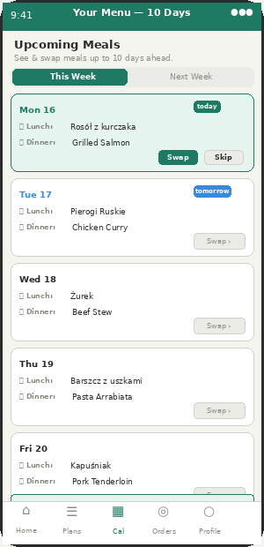
CA-12 — 10-day meal calendar with swap/skip per day

Aspect | Detail | What Appzeto Builds
How far ahead | Customer sees 10 days of upcoming meals in CA-12 Calendar. Each day shows: lunch meal name, dinner meal name, vendor. Days past cutoff show locked icon. | GET /api/subscriptions/{id}/upcoming?days=10 — returns next 10 delivery days with meal names. Vendor must have uploaded menu for those days or shows "Menu coming soon."
This week / Next week tabs | CA-12 Calendar has two tabs: This Week (Mon–Sun current) and Next Week. Customer taps tab to switch. Today always highlighted green. | Frontend: two tab views on CA-12. Backend query already handles date range — just extend from 2 days to 10 days. No structural backend change.
Swap from 10-day view | Customer can tap Swap on any upcoming day directly from the calendar. Opens meal selection for that date. Cutoff-locked days show lock icon, swap disabled. | CA-12 swap button per row. Routes to existing CA-12 swap flow. Cutoff validation unchanged — if past cutoff for that day, button disabled.
10-day ahead menu from vendor | Vendor must upload menu further in advance for 10-day preview to work. VM-06 Menu Management: encourage vendors to upload 2 weeks ahead. Show how many upcoming days have confirmed menus. | VM-03 Dashboard: "Menu uploaded for X of next 10 days." Nudge if less than 7 days confirmed. FCM reminder to vendor 48h before any unconfirmed day.
If menu not yet uploaded for a day | Calendar shows the date and slot but says "Maria's Kitchen — Menu uploading soon." Customer can still plan and will be notified when menu is confirmed. | meal.menu_status: confirmed | pending. CA-12 shows "Menu coming soon" with notification bell icon. Push sent to subscribed customers when vendor confirms menu for that date.
Admin control | ACM-171: admin sets how many days ahead the calendar preview shows. Default 10. Can reduce to 7 or 5 if vendor menu upload compliance is low at launch. | Remote Config: calendar_preview_days_ahead. Default 10. Applied in CA-12 frontend query. Admin changes OTA — no reinstall.

GAP AF — Family Box — Multi-Person Subscription
Screen: CA-09 Plans + CA-07 Checkout Priority: P1 Source: Be Diet Catering competitor research
MISSING FEATURE: Be Diet's "Rodzinny Box" (Family Box) allows one subscription covering 2–4 people. Same vendor, same delivery slot, one driver visit, multiple meal sets. DailyMealBox has B2B team ordering but no consumer-facing family subscription. This is a distinct product — household families, not offices.
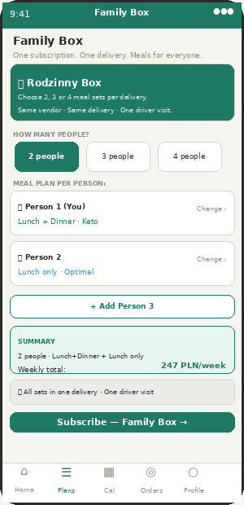
CA-09 — Family Box setup with per-person plan selection

Aspect | Detail | What Appzeto Builds
What it is | One subscription for 2, 3, or 4 people in the same household. Each person can have a different plan and slot (e.g. Person 1: Lunch+Dinner Keto, Person 2: Lunch only Optimal). One delivery per day, one driver visit. | subscription.family_box: {enabled: true, members: [{user_or_alias, plan_id, slots[]}]}. Billing: sum of all member plans. One delivery address.
Person setup in CA-09 | Customer selects "Family Box" on Plans tab. Chooses number of people (2/3/4). For each person: selects plan + slots. Summary shows combined weekly price. One checkout. | New CA-09 Family Box tab/section. Step flow: choose size → configure each person → checkout. Admin enables/disables via ACM-172.
Each person gets their own meal set | One delivery bag per person, labelled with name/initial. Driver drops all bags together. Vendor prepares separate labelled sets. | order.family_members: [{label: "Person 1 — Keto Lunch", meal_id}]. Vendor app VM-04 shows family order as grouped items. Each set labelled separately.
Pricing | Family Box = sum of individual plan prices. No family discount at launch (admin can add via ACM-172 if needed). Price breakdown shown per person at checkout. | checkout.line_items: [{person: "Person 1", plan, price}, {person: "Person 2", plan, price}]. Total = sum. VAT calculated per line.
Driver delivery | Driver sees Family Box orders as one stop with multiple sets. DA-04 route: "Maria K. — Family Box × 3 sets." Driver delivers all 3 sets at one address. | order.is_family_box: true. order.set_count: 3. DA-04 manifest: shows total set count per stop. Collection PIN covers all sets in one confirmation.
Vendor preparation | Vendor VM-04 Orders: Family Box order shown as grouped. "Family order × 3: 2× Keto Lunch, 1× Optimal Lunch." Prepare separately, label each set. | order.family_label: true. VM-04 order card: shows each family member's meal as a sub-line. "Prepare 3 separate labelled boxes for this order."

GAP AG — Select / Single Meal Ordering — No Subscription Required
Screen: CA-09 Plans + CA-01 Onboarding Priority: P1 Source: Be Diet Catering competitor research
MISSING FLOW: Be Diet's "Select" mode lets customer order a single meal today with no subscription commitment. DailyMealBox has one-time/on-demand orders but they require going through the same flow as subscription. Select is a standalone, frictionless single-meal ordering experience — the gateway product that converts first-time customers into subscribers.
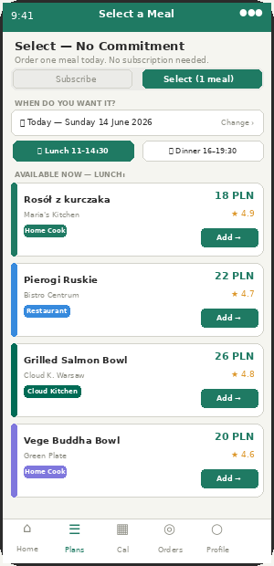
CA-09 — Select mode: single meal, no subscription, all vendor types visible

Aspect | Detail | What Appzeto Builds
What it is | Customer orders one meal for one slot today (or tomorrow). No subscription, no weekly plan, no commitment. Pay once, eat once. Shown as a mode toggle on CA-09 Plans tab: "Subscribe" vs "Select (1 meal)". | order.type: one_time_select. No subscription record created. One-time payment via Przelewy24/BLIK. Appears in CA-13 Orders as a single order entry.
Difference from existing one-time orders | Current one-time orders require going through onboarding and subscription flow first. Select is a standalone entry point — no onboarding needed, no subscription created. New customers can Select on their first visit. | New CA-09 flow: Plans tab has Subscribe/Select toggle. Select mode: show date picker (today/tomorrow), slot picker, then available meals for that slot. Add to cart → checkout → done.
What customer sees in Select mode | Date selector (today / tomorrow). Slot selector (available slots for that day/city). Meal list: all vendors available in customer zone for that slot, with photo, price, vendor name, rating. | GET /api/select-meals?date={date}&slot={slot}&zone={zone} — returns all available meals (same data as subscription browse, filtered to available portions today).
Why this converts to subscription | After delivery: "Enjoyed your meal? Subscribe to Maria's Kitchen and get this every week — skip or swap anytime." One-tap subscribe from order confirmation. | Post-delivery push: "Subscribe to {vendor}?" Deep link to CA-07 checkout with vendor pre-selected. Conversion tracking: select_order → subscription_conversion. Admin sees in AP-11 analytics.
Pricing | Select meal = meal price + delivery fee (full rate, no subscription discount). No minimum commitment. Clearly shown at checkout. | Delivery fee: one_time rate (higher than subscription rate per ACM-21 delivery fee hierarchy). Clearly labeled "One-time order — subscribe to save on delivery."
Admin control | ACM-173: enable/disable Select mode per city. Default: enabled. Admin can disable during high-demand periods if kitchen capacity is prioritised for subscribers. | Remote Config: select_mode_enabled_{city}. If false: Select tab hidden from CA-09. Only Subscribe mode shown.

GAP AH — Medically Specific Diet Plans
Screen: CA-09 Plans Browse + VM-02 Vendor Registration Priority: P2 Source: Be Diet Catering competitor research
MISSING CATEGORY: Be Diet offers plans specifically designed for Hashimoto (thyroid disease), pregnancy (Mom2Be), menopause, and low GI/diabetic customers. These plans command premium pricing and exceptional customer loyalty — medical diet customers rarely churn because there is no comparable alternative. DailyMealBox currently has diet categories (Vegan/Keto/Gluten-free) but no medically-specific plans with clinical backing.
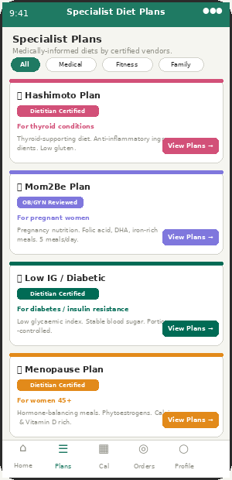
CA-09 — Specialist Plans tab with medical diet categories and dietitian certification badge

Aspect | Detail | What Appzeto Builds
New vendor sub-type: Medical Diet Specialist | Vendor can apply as a Medical Diet Specialist in addition to their existing vendor type. Requires: certified dietitian collaboration (document upload), specific plan approval by admin. | vendor.specialisms: ["hashimoto","pregnancy","low_gi","menopause"]. Admin approves each specialism separately. VM-02 registration: new "Specialisms" section after vendor type selection.
4 initial medical plan categories | (1) Hashimoto/Thyroid — anti-inflammatory, low gluten, selenium-rich. (2) Mom2Be/Pregnancy — folic acid, DHA, iron, no raw fish/unpasteurised. (3) Low GI/Diabetic — glycaemic index controlled, portion-managed. (4) Menopause — phytoestrogens, calcium, vitamin D. | New meal.plan_category field: standard|keto|vegan|hashimoto|pregnancy|low_gi|menopause. CA-09 filter chip: "Medical Plans." Shows only meals/vendors with relevant specialism.
"Dietitian Certified" badge on listings | Vendors with approved medical specialism show a "Dietitian Certified" badge on their CA-09 listing and CA-11 meal detail. Builds trust. Admin approves badge per vendor per specialism. | vendor.certifications[]: {type: "dietitian", specialism, issued_by, document_url, approved_by_admin, expiry_date}. CA-09 listing: show badge if certification active. Badge auto-removed if expired.
Customer filter for medical plans | CA-09 Plans tab: new filter chip "Specialist Plans." Expands to show 4 medical categories. Customer selects their condition → shows only certified vendors/plans for that category. | CA-09 filter: plan_category chip → expands to sub-options. GET /api/plans?specialisms={category}. Returns vendors with matching approved specialism.
Admin approval workflow for medical specialisms | City Manager reviews: dietitian credential document, sample meal plan, allergen compliance for the specific condition. Approve or reject with reason. Auto-expire review every 12 months. | AP-05 vendor profile: new "Medical Specialisms" section. Approve/reject per specialism. Expiry reminder 60 days before. Auto-suspend specialism if document expired.
Phase approach | Phase 1 (launch): accept vendors who have existing dietitian collaboration and upload credentials. No additional testing. Phase 2: DailyMealBox partners with registered dietitian to validate plans before badge granted. | Phase 1: admin manually reviews credential document. Phase 2: dietitian partner reviews and signs off. Badge updated to "DailyMealBox Verified" for Phase 2 vendors.

New ACM Controls — ACM-171 to ACM-175

ADD TO ADMIN CONTROLS MATRIX: 5 new admin controls from Addendum 3. Add to Admin Controls Matrix. Running total: 175 controls (ACM-1 to ACM-175).
ACM# | Feature | Who Can Change | Default | Notes
171 | Calendar preview days ahead (10-day menu) | Super Admin | 10 days | How many days ahead CA-12 shows upcoming meal names. Reduce to 7 or 5 if vendor menu upload compliance is low at launch.
172 | Family Box subscription — enable/disable per city | Super Admin | Enabled | Enable/disable Family Box (2–4 person subscription) per city. Admin can also set family discount % if applicable.
173 | Select mode (single meal, no subscription) — enable per city | Super Admin | Enabled | Enable/disable Select one-time meal ordering per city. Admin can disable during high-demand periods to prioritise subscriber capacity.
174 | Medical diet specialism — enable vendor applications | Super Admin, City Manager | Enabled | Allow vendors to apply for medical diet specialism badges. Admin approves each specialism per vendor individually.
175 | Dietitian Certified badge — validity period | Super Admin | 12 months | How long a dietitian certification badge is valid before requiring renewal. Default 12 months. Auto-removes badge if vendor does not renew.

Confirm with Appzeto — Addendum 3

Priority | Item | Detail
P1 | 10-day calendar preview — CA-12 extended to show 10 upcoming meal days | Extend /api/subscriptions/{id}/upcoming query from 2 days to 10 days. CA-12 frontend: two tabs (This Week / Next Week). Swap button per row. "Menu coming soon" state when vendor has not yet uploaded.
P1 | Family Box subscription — new subscription type with multiple members | New subscription.family_box structure. CA-09 Family Box flow. VM-04 grouped family order display. DA-04 manifest shows set count. One delivery address, one PIN, multiple labelled sets.
P1 | Select mode — single meal ordering without subscription | New CA-09 Subscribe/Select toggle. Select flow: date → slot → meal → pay. order.type: one_time_select. Post-delivery subscription conversion push. Admin toggle ACM-173 per city.
P2 | Medical diet specialism — vendor badge and customer filter | vendor.specialisms[] field. VM-02 specialism application sub-step. CA-09 Specialist Plans filter. "Dietitian Certified" badge on listings. AP-05 specialism approval workflow. 12-month badge expiry.

FINAL STATUS: Running total of ACM controls after Addendum 3: 175 (ACM-1 to ACM-175). Full amendment history: v2 (18 items) + v2 Pantry Box (8 items) + Competitor gap audit v2 (26 items, ACM-146–160) + Qoox Addendum / Gap AA (ACM-161–165) + Addendum 2 / Gaps AB–AD (ACM-166–170) + Addendum 3 / Gaps AE–AH (ACM-171–175). Total specification items: 91+. 175 admin controls. 5 apps. 3 markets.
DailyMealBox — Amendment v2 + Addendum 3 (Be Diet Gaps) · 14 June 2026 · Gaps AE–AH · ACM-171 to ACM-175 · 175 total controls · dailymealbox.com

ADDENDUM 4 — DIETLY COMPETITOR GAPS · 2 NEW FEATURES
Added 14 June 2026 · Source: dietly.pl competitor research · Gaps AI–AJ · ACM-176 to ACM-177

RESEARCH FINDING: Research of Dietly.pl (Poland's largest diet catering marketplace, owned by Żabka Group) identified 12 features. Most were already in DailyMealBox or confirmed as existing. Two confirmed missing features are added here: eco packaging badge/filter and weekend delivery filter. All other Dietly features (reviews, ratings, calorie filter, price filter, zone filter) are already in DailyMealBox spec.
Gap | Title | Screens Affected | Priority
AI | Eco Packaging Vendor Badge + Filter | CA-09 Plans, VM-02 Registration, AP-05 | P1
AJ | Weekend Delivery Filter (Saturday / Sunday) | CA-09 Plans, VM-14 Cutoff Settings, CA-05 | P1

GAP AI — Eco Packaging Vendor Badge + Filter
Screens: CA-09 Plans browse · VM-02 Registration · VM-12 Profile · AP-05 Vendor Management Priority: P1 Source: Dietly.pl competitor research
MISSING: Dietly shows an eco packaging filter and badge on vendor listings. Polish diet catering customers are increasingly eco-conscious — vendors using biodegradable or recyclable packaging want to communicate this and customers want to find them. Currently DailyMealBox has no eco packaging attribute on vendors.
Aspect | Detail | What Appzeto Builds
Vendor declares eco packaging in VM-02/VM-12 | During registration (VM-02) and in their profile (VM-12): vendor ticks "We use eco-friendly packaging" and selects type: Biodegradable boxes / Recyclable plastic / Paper-based / Reusable containers. Uploads supporting photo (optional). | vendor.eco_packaging: {enabled: boolean, type: "biodegradable"|"recyclable"|"paper"|"reusable", photo_url: string|null}. Set in VM-02 registration step and editable in VM-12 profile.
Admin verifies eco claim in AP-05 | Admin reviews vendor eco packaging declaration in AP-05 vendor profile. Can approve (badge shown) or mark as unverified (badge not shown). Admin can require vendors to upload packaging photo as proof before badge is granted. | vendor.eco_packaging.admin_verified: boolean. If false: badge not shown to customers. AP-05: "Verify Eco Badge" button per vendor. ACM-176 lets admin make verification mandatory vs self-declared.
🌿 Eco badge on CA-09 Plans listing | Verified eco vendors show a small green "🌿 Eco" badge on their plan card in CA-09. Visible at a glance without opening the vendor detail. Also shown prominently on CA-11 meal detail screen. | plan_card: show eco badge if vendor.eco_packaging.enabled AND vendor.eco_packaging.admin_verified. CA-11 meal detail: "Packaging: Biodegradable boxes 🌿" below vendor info.
Eco filter chip in CA-09 | CA-09 Plans browse: new filter chip "🌿 Eco Packaging" alongside existing Goal/Diet/Price/Zone chips. When selected: only shows vendors with verified eco packaging. Filter can be combined with other filters. | CA-09 filter: eco_packaging=true param in GET /api/plans query. Backend: WHERE vendor.eco_packaging.enabled=true AND vendor.eco_packaging.admin_verified=true.
Eco packaging in customer onboarding (CA-04) | CA-04 Dietary Preferences: new optional preference "🌿 I prefer eco-friendly packaging." If selected: eco vendors shown higher in CA-06 Recommended Plans. Not a hard filter — just a ranking boost. | user.preferences.eco_preference: boolean. CA-06 ranking: vendors with eco_packaging.verified get +0.2 score boost if user.preferences.eco_preference=true.

GAP AJ — Weekend Delivery Filter (Saturday / Sunday)
Screens: CA-09 Plans browse · CA-05 Schedule · VM-14 Cutoff Settings · AP-08 Slot Management Priority: P1 Source: Dietly.pl competitor research
MISSING: Dietly has a specific filter for vendors who deliver on Saturday and/or Sunday. Many catering companies in Poland only deliver Mon–Fri. Customers who want weekend delivery need a way to find vendors who offer it. DailyMealBox currently has delivery days selection (Mon–Fri / Full Week) but no filter in CA-09 Plans to surface only weekend-capable vendors.
Aspect | Detail | What Appzeto Builds
Vendor declares weekend delivery capability in VM-14 | VM-14 Cutoff Settings: vendor selects which days they deliver. Current options: Mon / Tue / Wed / Thu / Fri. Add: Sat / Sun as toggleable options per slot. Vendor who enables Saturday gets a weekend delivery capability flag. | vendor.delivery_days: array of day numbers [1,2,3,4,5,6,7]. 6=Saturday, 7=Sunday. VM-14: checkbox per day per slot. Default: Mon–Fri only. Vendor enables weekend days if they have kitchen and driver capacity.
Saturday / Sunday filter in CA-09 | CA-09 Plans browse: two new filter chips — "📅 Saturday delivery" and "📅 Sunday delivery." When selected: shows only vendors who deliver on that day. Customer selecting a full-week subscription especially needs this. | CA-09 filter chips: delivers_saturday=true / delivers_sunday=true. Backend: WHERE {sat_day} IN vendor.delivery_days. Independent filters — customer can select Saturday only, Sunday only, or both.
Weekend badge on plan cards in CA-09 | Vendors who deliver on weekends show a small "Sat ✓" or "Sun ✓" or "7 days" badge on their plan card. At a glance, customer knows this vendor covers weekends without opening the detail. | plan_card: if vendor.delivery_days includes 6 → show "Sat ✓" badge. If includes 7 → show "Sun ✓" badge. If includes both → show "7 days" badge in green. Badge color: green.
Customer selects weekend days in CA-05 | CA-05 Delivery Schedule: "Full Week (Mon–Sun)" option already exists. Enhancement: show a note "Not all vendors deliver on weekends — weekend-capable vendors will be shown." Link directly to weekend-filtered CA-09. | CA-05: if customer selects full week or custom days including Sat/Sun → show info note. "We will only show you vendors who deliver on your selected days." CA-06 Recommended Plans filtered to weekend-capable vendors automatically.
Weekend slot management in AP-08 | AP-08 Slot Management: each delivery slot now shows "Available days" including Sat/Sun checkboxes. Admin can enable Saturday/Sunday as available delivery days platform-wide per city. Without admin enabling, vendors cannot select weekend delivery even if they want to. | slot_types.available_days: array. Admin enables Sat/Sun per slot per city via ACM-177. Default: Mon–Fri only at Warsaw launch. Admin enables weekend delivery city-wide when enough vendors and drivers are available.
Driver shift for weekend delivery | Weekend delivery requires weekend driver shifts. AP-08 Slot Management: admin creates Saturday and Sunday shift variants. Drivers opt in to weekend shifts separately. ACM-177 controls weekend availability per city. | shift_types: existing weekday shifts get weekend variants. Driver DA-11 schedule: can show weekend shifts if admin has enabled them. Driver opts in to Sat/Sun shifts voluntarily — not mandatory.

New ACM Controls — ACM-176 to ACM-177

ADD TO ADMIN CONTROLS MATRIX: Running total after Addendum 4: 177 admin controls (ACM-1 to ACM-177).
ACM# | Feature | Who Can Change | Default | Notes
176 | Eco packaging badge — require admin verification before badge shown | Super Admin, City Manager | Verification required | If ON: admin must verify vendor eco claim before badge appears on CA-09. If OFF: self-declared (badge shown immediately on vendor declaration). Recommended: verification ON to prevent false eco claims.
177 | Weekend delivery (Saturday/Sunday) — enable per city per slot | Super Admin, City Manager | Disabled (Warsaw launch) | Admin enables Saturday and/or Sunday delivery per slot per city. Only when enabled can vendors select weekend delivery in VM-14. Enable when enough vendors and drivers are available for weekend shifts.

ADDENDUM 5 — SMART SUBSCRIPTION ROTATION · GAP AK
Added 14 June 2026 · Gap AK — Smart Rotation · ACM-178 to ACM-181 · 2 new screens

GAP AK — WHAT IT IS: Currently DailyMealBox subscriptions are tied to ONE specific vendor — a customer subscribes to Maria's Kitchen and gets Maria's Kitchen every day. Smart Rotation allows a customer to build a personalised rotation of 2–5 makers from their delivery zone — different kitchen each day. ADMIN CONTROLLED: feature is OFF by default. Admin must enable per city before any customer can access it.
STATUS: CONFIRMED MISSING: Verified against all PRD documents (Parts 1–4) and all previous amendments. No rotation or multi-vendor subscription logic exists anywhere. This is a brand new feature.
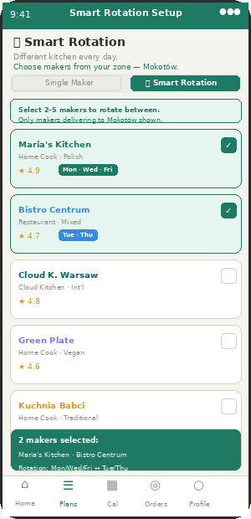  CA-09 — Customer selects 2–5 makers from their zone to rotate between | 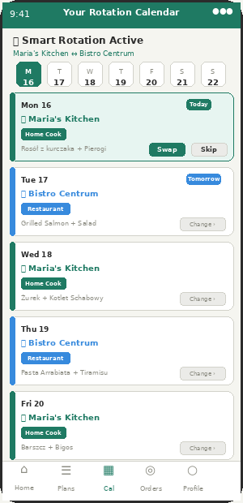  CA-12 — Rotation calendar: different maker shown per day, swap/skip per day

Gap AK — Full Specification

Aspect | Detail | What Appzeto Builds
Admin toggle — enable Smart Rotation per city (ACM-178) | Smart Rotation is OFF by default everywhere. Super Admin or City Manager enables it per city. When OFF: the "Smart Rotation" tab/option is completely hidden from all customers in that city. When ON: customers see the option alongside Single Maker subscription in CA-09 Plans. | Remote Config: smart_rotation_enabled_{city}. Default: false. If false: CA-09 Plans tab shows no rotation option — completely hidden. City Manager can enable for their city. Super Admin enables platform-wide.
Customer chooses Smart Rotation in CA-09 Plans | When admin has enabled Smart Rotation for the city: CA-09 Plans tab shows a mode toggle — "Single Maker" vs "🔄 Smart Rotation." Customer taps Smart Rotation to set up their rotation. They see a filtered list of available makers IN THEIR ZONE ONLY (same zone filtering as regular plans). Customer selects 2 to 5 makers from this list. | GET /api/vendors?zone_id={customer_zone}&rotation_capable=true — returns only vendors in customer zone who have sufficient days/capacity for rotation. CA-09 shows checklist UI — customer ticks makers they want. Min 2, max 5 (ACM-179 controls max makers in rotation).
Only makers within customer zone are shown | This is enforced at the backend — not a soft filter. API only returns vendors whose delivery_zones array includes the customer's zone_id. Customer cannot select a maker from a different zone even if they know the vendor exists. Zone restriction is identical to regular subscription zone filtering. | GET /api/vendors filtered by: zones includes customer.zone_id AND vendor.status = active AND vendor.rotation_available = true. No vendor from outside customer zone ever appears in the rotation picker.
Customer assigns makers to specific days | After selecting makers, customer assigns them to delivery days. Example: Maria's Kitchen → Mon/Wed/Fri. Bistro Centrum → Tue/Thu. OR customer can let system auto-assign (round-robin). Each maker must have at least 1 day assigned. Days must add up to customer's chosen delivery schedule (e.g. if Mon–Fri, all 5 days covered). | subscription.rotation_schedule: {vendor_id: [day_numbers]}. E.g. {maria_id: [1,3,5], bistro_id: [2,4]}. Validation: union of all day arrays must equal subscription.delivery_days. No day can be assigned to two vendors.
CA-12 Calendar shows different maker per day | CA-12 Calendar: each day card shows the maker scheduled for that day with their color coding. Monday shows Maria's Kitchen (green), Tuesday shows Bistro Centrum (blue). Customer can see the full rotation pattern across the 10-day preview (Gap AE). Swap/Skip/Reschedule still work per day as normal. | CA-12: day card renders vendor name + color based on subscription.rotation_schedule[date.dayOfWeek]. Swap on a rotation day: customer can pick any meal from THAT DAY's assigned vendor (same vendor, different meal) — not switch to a different vendor.
Meal shown for each day from the assigned maker | Each day on CA-12 shows the meal from the assigned maker for that day — same as regular subscription (vendor uploads menu in advance). "Menu coming soon" shown if vendor has not yet uploaded for that date. 10-day preview (Gap AE) works across multiple vendors in the rotation. | meal_for_date: JOIN orders ON date=delivery_date AND vendor_id = rotation_schedule[date.dayOfWeek]. Same logic as single-vendor subscription but vendor_id changes per day based on rotation schedule.
Billing — one subscription, multiple vendors | Customer pays one weekly/monthly subscription price — but the amount varies because each vendor may have different meal prices. Billing = sum of (each vendor's meal price × days assigned to them). Shown clearly at checkout: "Maria's Kitchen × 3 days = 54 PLN, Bistro Centrum × 2 days = 44 PLN. Weekly total = 98 PLN." | subscription.weekly_cost = SUM(vendor.meal_price × assigned_days_count for each vendor in rotation). Calculated at setup and recalculated if vendor changes their meal price. Customer notified if price changes: "Maria's Kitchen updated their meal price — your weekly cost is now X PLN."
Changing the rotation — modify from CA-15 Profile | Customer can edit their rotation at any time from CA-15 Profile → Subscription Management → Edit Rotation. Changes take effect from next billing cycle. Cannot change rotation for days that have already passed the cutoff for that vendor. | PATCH /api/subscriptions/{id}/rotation — updates rotation_schedule. Effective from: next Monday (or next billing cycle start). Validation: new schedule must still cover all delivery days. Cutoff-locked days in current week cannot be changed.
What vendors see — separate orders per vendor | Each vendor in the rotation sees only their own orders — exactly as in a regular subscription. Maria's Kitchen sees Mon/Wed/Fri orders. Bistro Centrum sees Tue/Thu orders. Neither vendor knows the customer is also ordering from the other. VM-NEW-01 Food Forecast works normally per vendor — just for their assigned days. | order.subscription_id: same subscription ID for all rotation days. order.vendor_id: the specific vendor for that day. Vendor query: WHERE vendor_id = {my_id} — only sees their own orders. No cross-vendor visibility.
Driver route — rotation has no impact on driver | From the driver's perspective, rotation is invisible. DA-04 Route shows today's pickups — which happen to be from Maria's Kitchen on Monday. The driver does not know or need to know the customer has a rotation. Next day the driver picks up from Bistro Centrum — again, no difference in driver app experience. | No change to driver app. VRPTW algorithm processes orders as normal — pickup vendor changes day to day but route logic is identical. Driver always sees today's vendor for each delivery stop.
Admin view in AP-05 — rotation subscriptions flagged | AP-05 Vendor Management: subscription count for each vendor shows rotation subscribers separately. "42 subscribers (38 dedicated, 4 rotation)." City Manager can see total rotation subscriptions active in their city in AP-11 Analytics. | subscription.type: dedicated | rotation. AP-05 vendor profile: subscriber_count_dedicated + subscriber_count_rotation. AP-11 new metric: rotation_subscriptions_active per city.

Key Rules Summary

ADMIN CONTROLS (Rules) | CUSTOMER RULES
ACM-178: OFF by default. Admin enables per city. | Must select 2–5 makers minimum. Cannot have rotation of 1.
ACM-179: Admin sets max makers in one rotation (default 5). | Only makers in customer's own zone are visible for selection.
ACM-180: Admin can disable rotation for specific vendor types (e.g. disable home cooks from being in rotations if needed). | Each day must be assigned to exactly one maker. No day can be shared.
ACM-181: Admin sets minimum days per maker in rotation (default 1 day minimum per maker). | Rotation changes take effect next billing cycle — not mid-week.
City Manager sees rotation subscription count per vendor in AP-05. | Swap on a rotation day = swap meal within same maker, not switch maker.
Super Admin can force-disable Smart Rotation platform-wide instantly. | Cutoff rules apply per maker — each maker has their own cutoff time.

New ACM Controls — ACM-178 to ACM-181

ADD TO ADMIN CONTROLS MATRIX: Running total after Addendum 5: 181 admin controls (ACM-1 to ACM-181).
ACM# | Feature | Who Can Change | Default | Notes
178 | Smart Rotation — enable/disable per city | Super Admin, City Manager | DISABLED everywhere | Must be explicitly enabled by admin before any customer can see or use Smart Rotation. Completely hidden from customer app when OFF. Enable per city when sufficient vendor variety exists in each zone.
179 | Smart Rotation — maximum makers per rotation | Super Admin | 5 makers maximum | How many makers a customer can include in one rotation. Default 5. Admin can reduce (e.g. 3 max) if vendor density per zone is low. Minimum is always 2 (enforced in code — not configurable below 2).
180 | Smart Rotation — allowed vendor types | Super Admin, City Manager | All vendor types allowed | Admin can restrict which vendor types can appear in rotation selections. E.g. disable Home Cook type from rotation if they have inconsistent availability. Vendor type must be enabled in ACM-48 AND in this control.
181 | Smart Rotation — minimum days per maker in rotation | Super Admin | 1 day minimum | Minimum number of days that must be assigned to each maker in a rotation. Default 1. Admin can increase to 2 to ensure vendors get viable order volumes from rotation subscribers rather than just 1 sporadic day per week.

DailyMealBox — Amendment v2 + Addendum 5 (Smart Rotation) · 14 June 2026 · Gap AK · ACM-178 to ACM-181 · 181 total controls · dailymealbox.com

ADDENDUM 6 — HOT / COLD MEAL TEMPERATURE LABEL · GAP AL
Added 15 June 2026 · Gap AL · ACM-182 to ACM-183 · 2 new screens

STATUS — CONFIRMED MISSING: Confirmed NOT in spec — verified across Parts 1, 2, and all amendments. No meal temperature attribute exists anywhere in the PRD. This is a new feature.
WHAT IT IS: Meals are either: (1) 🔥 HOT — freshly cooked, delivered hot, ready to eat, maximum 1–2 hours from cooking to delivery. Or (2) ❄ COLD — pre-packed, delivered chilled, customer reheats or grills before eating. Vendor selects one when listing a meal in VM-07. Customer sees the icon on CA-09 listing and CA-11 meal detail. Admin controls which icons are displayed (both / hot only / cold only).
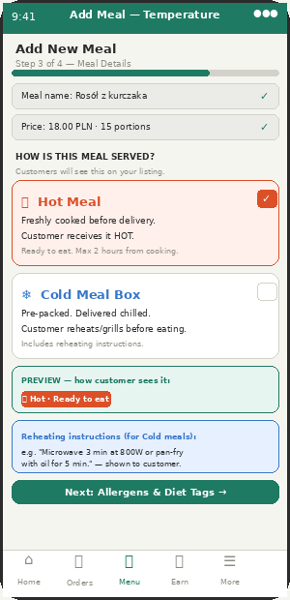  VM-07 — Maker selects Hot or Cold when adding a meal. Cold meals show reheating instructions field. | 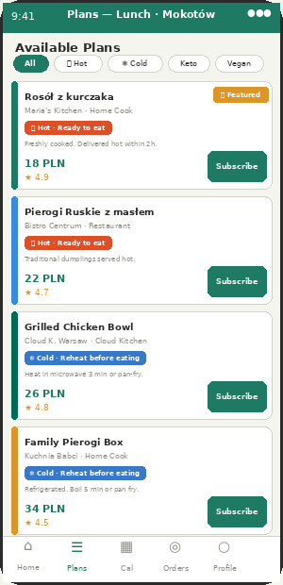  CA-09 — 🔥 Hot and ❄ Cold badges on meal cards. Filter chips let customer browse by temperature.

Gap AL — Full Specification

Aspect | Detail | What Appzeto Builds
Vendor selects temperature type in VM-07 — mandatory field | When a maker adds or edits a meal in VM-07 (Add/Edit Meal), a mandatory "How is this meal served?" section appears. Two large option cards: 🔥 Hot Meal and ❄ Cold Meal Box. Must select one before meal can be published. Cannot skip this field — meal stays in Draft if not selected. | meal.temperature_type: "hot" | "cold". Required field — validation blocks publish if null. VM-07 form: two large selectable cards with icon, label, and description of each. Selected card highlighted in respective color (hot = orange-red, cold = blue).
🔥 Hot Meal — definition and rules | Freshly cooked before delivery. Customer receives the meal HOT and ready to eat. Vendor commits that the meal is cooked within 2 hours of the delivery window. No reheating needed by customer. Examples: Rosół z kurczaka, Pierogi Ruskie, soups, stews, grilled dishes. | meal.temperature_type = "hot". meal.max_cooking_to_delivery_hours = 2 (enforced by delivery slot timing — vendor must mark ready within window). Customer-facing label: "🔥 Hot · Ready to eat".
❄ Cold Meal Box — definition, rules, and reheating instructions | Pre-packed and delivered chilled. Customer must reheat or grill before eating. When vendor selects Cold: a "Reheating instructions" text field appears (max 150 characters). Vendor writes e.g. "Microwave 3 min at 800W" or "Pan-fry with oil 5 min each side." These instructions are shown to the customer on CA-11 meal detail. | meal.temperature_type = "cold". meal.reheat_instructions: string (max 150 chars), required when temperature_type = cold. Shown on CA-11: "Reheating: Microwave 3 min at 800W." Also shown on DA-06 driver screen as a note: "Cold delivery — ensure insulated bag used."
Hot/Cold badge on CA-09 Plans listing | Every meal card in CA-09 shows the temperature badge prominently below the vendor name. Hot meals: 🔥 orange-red badge "Hot · Ready to eat." Cold meals: ❄ blue badge "Cold · Reheat before eating." Admin controls which badges are shown via ACM-182 — can show both, hot only, or cold only. | CA-09 plan_card: render badge based on meal.temperature_type. Hot: background #DC5028, white text, 🔥 icon. Cold: background #3778C8, white text, ❄ icon. Badge visibility controlled by Remote Config: show_temperature_labels (both|hot_only|cold_only|hidden).
Hot/Cold badge on CA-11 Meal Detail | CA-11 Meal Detail screen shows temperature badge prominently in the meal info section. For Cold meals: reheating instructions shown below the badge in a clearly labeled box. For Hot meals: "Served hot — ready to eat on arrival" shown. | CA-11 meal detail: temperature badge (same colors as CA-09). If cold: show reheat_instructions in a blue-tinted box below badge. If hot: show "🔥 Served hot — ready to eat on arrival" text.
Temperature filter chip in CA-09 | CA-09 Plans browse: two new filter chips alongside existing filters — "🔥 Hot" and "❄ Cold." Customer can filter to see only hot meals (ready to eat) or only cold meal boxes (need to reheat). Chips only visible if admin has enabled both labels (ACM-182). If admin set hot_only: only 🔥 Hot chip shown. If admin set hidden: no temperature chips shown. | CA-09 filter: temperature_type=hot or temperature_type=cold param. Backend: WHERE meal.temperature_type = {filter}. Filter chips rendered based on ACM-182 Remote Config value — hidden chips do not appear even if customer manually tries to apply.
Driver informed for Cold meals — insulated bag reminder | DA-06 Delivery Screen: if any order in driver's route is a cold meal, driver sees a reminder at the top of their route: "❄ Cold meals in today's route — use insulated bag." Appears at start of shift, not per individual delivery stop. | DA-04 route generation: if any order.meal.temperature_type = cold, set route.has_cold_meals = true. DA-04 Route Screen: show amber banner "❄ Cold meals today — insulated bag required" if has_cold_meals.
Admin controls — ACM-182 visibility, ACM-183 mandatory for vendors | ACM-182: admin sets which temperature labels customers see — Both (🔥 and ❄) / Hot only / Cold only / Hidden (no labels). Default: Both. Useful if at launch most vendors only offer hot meals and cold label would confuse customers. ACM-183: admin sets whether temperature selection is mandatory for vendors. Default: mandatory. Can set to optional during onboarding phase to reduce vendor friction. | Remote Config: temperature_label_display (both|hot_only|cold_only|hidden). Default: both. temperature_selection_mandatory (true|false). Default: true. If false: VM-07 shows temperature field as optional. Meals without temperature_type: no badge shown on CA-09/CA-11.
Existing meals — migration | All meals already in the system at the time this feature is deployed will have temperature_type = null. They show no badge until vendor updates their meal. Admin can bulk-nudge vendors: "Please update your meal listings with temperature type." Push notification + email sent to all vendors. | migration: meal.temperature_type = null for all existing meals. VM-07 edit meal: temperature field shows as "Not set — please update." Admin AP-05: "Send temperature update reminder" bulk action — FCM to all vendors with meals that have null temperature_type.

New ACM Controls — ACM-182 to ACM-183

ADD TO ADMIN CONTROLS MATRIX: Running total after Addendum 6: 183 admin controls (ACM-1 to ACM-183).
ACM# | Feature | Who Can Change | Default | Notes
182 | Temperature label display — which icons customers see | Super Admin, City Manager | Both (🔥 Hot and ❄ Cold) | Controls which temperature badges appear on CA-09 listings and CA-11 detail. Options: Both / Hot only / Cold only / Hidden. Also controls which filter chips appear in CA-09. Set to Hot only at Warsaw launch if most vendors offer hot meals only.
183 | Temperature type — mandatory field for vendors in VM-07 | Super Admin | Mandatory | If ON: vendors cannot publish a meal without selecting Hot or Cold. If OFF: temperature selection is optional in VM-07 — meals without it show no badge on customer listing. Recommended: ON always. Set OFF only during initial vendor onboarding to reduce friction, then switch ON after launch.

Confirm with Appzeto — Gap AL

Priority | Item | Detail
P0 | meal.temperature_type field: "hot" | "cold" | null — mandatory in VM-07 | New field on meal collection. Required on publish (null blocks publish). VM-07 form: two large card options. Cold selection reveals reheat_instructions text field (required if cold). Existing meals: null until vendor updates. Migration nudge push to vendors.
P0 | Temperature badge on CA-09 plan cards and CA-11 meal detail | 🔥 Hot badge: #DC5028 background, white text. ❄ Cold badge: #3778C8 background, white text. CA-11 cold meals: show reheat_instructions in blue box. Badge visibility: controlled by ACM-182 Remote Config. Null temperature_type: no badge shown.
P1 | Temperature filter chips in CA-09 — Hot and Cold filter options | Two new filter chips in CA-09. Visible only if ACM-182 = both or matching single type. Backend filter: WHERE meal.temperature_type = {value}. Combined with other filters (diet, zone, price).
P1 | Driver insulated bag reminder for cold meal routes in DA-04 | Route generation: if any order has cold meal, set route.has_cold_meals = true. DA-04 Route Screen: amber banner at top of screen. "❄ Cold meals in today's route — use insulated bag." Shown once per shift, not per delivery stop.

FINAL STATUS: Running total of ACM controls after Addendum 6: 183 (ACM-1 to ACM-183). Full history: v2 (18) + v2 (8) + v2 core (26, ACM-146–160) + Qoox/AA (5, ACM-161–165) + Addendum 2/AB–AD (5, ACM-166–170) + Addendum 3/AE–AH/Be Diet (5, ACM-171–175) + Addendum 4/AI–AJ/Dietly (2, ACM-176–177) + Addendum 5/AK/Smart Rotation (4, ACM-178–181) + Addendum 6/AL/Hot-Cold Label (2, ACM-182–183). Total: 97+ specification items. 183 admin controls. 5 apps. 3 markets.
DailyMealBox — Amendment v2 + Addendum 6 (Hot/Cold Label) · 15 June 2026 · Gap AL · ACM-182 to ACM-183 · 183 total controls · dailymealbox.com

